Lab # Customizations

Hands-on lab Step-by-Step

September 2021

# Lab Overview and Pre-requisites

This beginner-level lab gives you hands-on experience designing and developing a virtual agent, customer voice and adding images to sub grid in Model Driven Apps.

Here’s what you’ll learn:

* **Power Virtual Agent:** Create a Virtual Agent to answer top topics to offboard agent workload.
* **Customer Voice:** Create survey to be sent after completing case from chatbot.
* **Form Customization:** Adding command bar to show image from the Product sub grid in Opportunity form in Model Driven Apps.

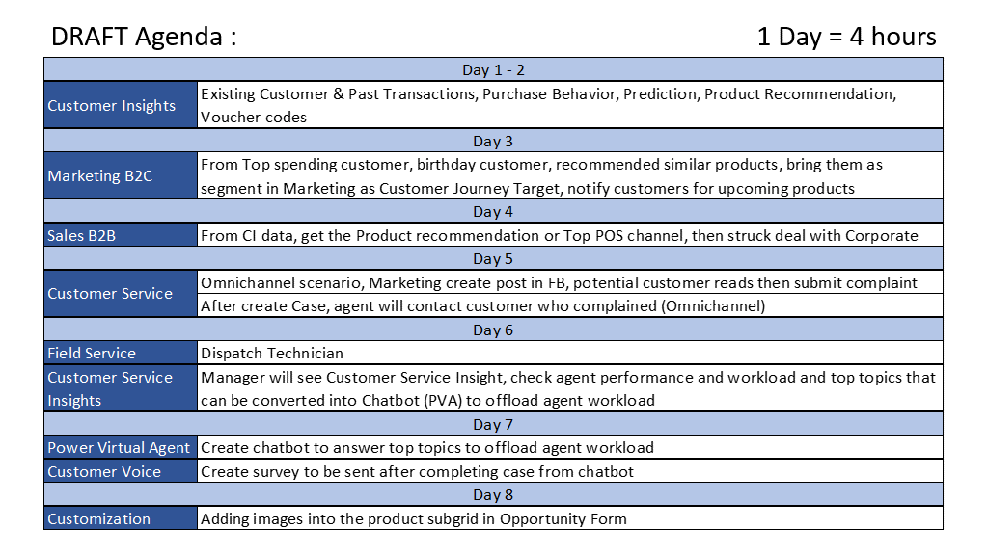

admin@CRM688152.onmicrosoft.com

N3y6428vjC

# Goal for Lab #:

|  |  |  |  |
| --- | --- | --- | --- |
|  | This lab assumes that you have laid out the groundwork for your bot. If not, you will need to:   * Setup a trial for Customer Service Insights * Setup a trial for Power Virtual Agent   Once you have completed all the prerequisites above, you will:   * Create a bot from a specified topic in Customer Service Insights * Publish the bot to the portal or Facebook Messenger |  | The time to complete this lab is [45] minutes. |

# Exercise 1: Automate topics for a Power Virtual Agents bot

You must have the following to automate a topic from Customer Service Insights to Power Virtual Agents:

* A valid license to access Power Virtual Agents. Go to <https://aka.ms/TryPVA> for more information and to sign up for a trial.
* A bot created in Power Virtual Agents.

## Task 1: Enabling Bot Automation from Customer Analytics

1. Navigate to Service Management area

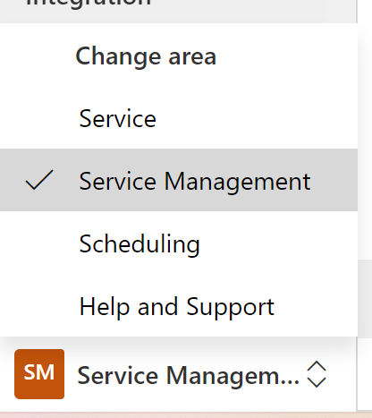

1. Select **Settings** in **Insights** group.

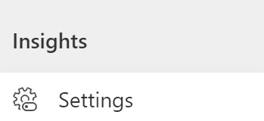

1. Select **Manage on topic clustering for case** then go to the bottom area of the page.

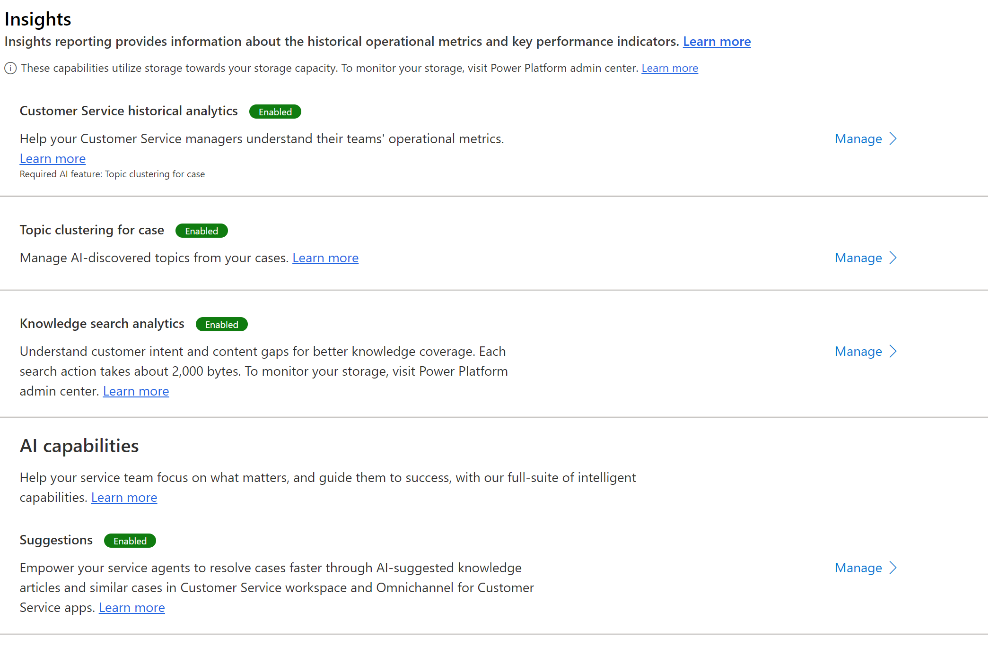

1. Enable Power Virtual Agents.

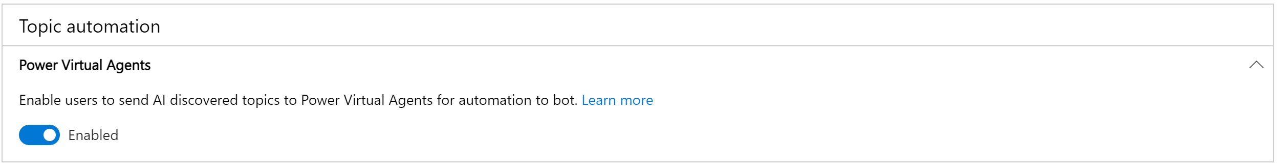

You can see Analytics reports by navigating to the Service > Analytics and Insights > Customer Service historical analytics page. By default, the Summary page is displayed.

After reviewing topic details and identifying a candidate for automation, you can automate the topic from the topic details page:

1. In the topic details page, select **Automate to bot** at the top.

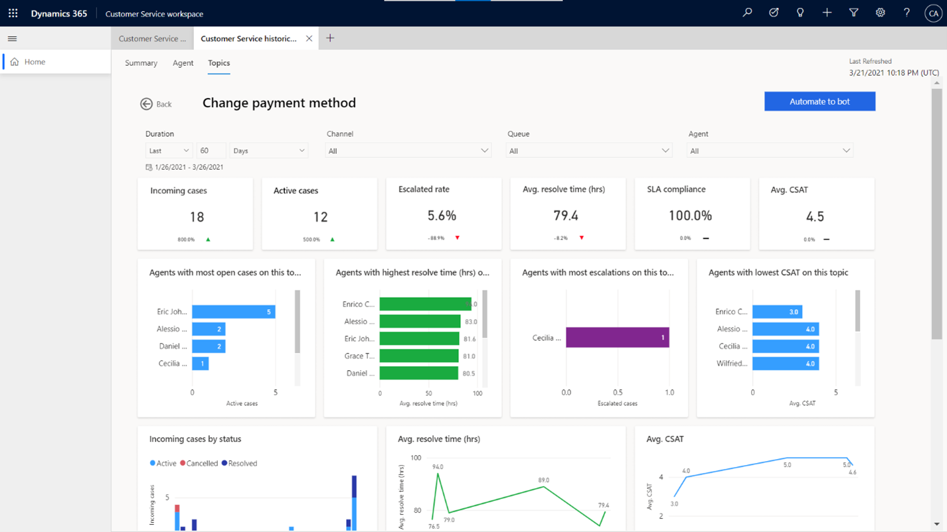

1. Customer Service Insights creates a new topic in Power Virtual Agents in a new browser tab.

The Name and Trigger phrases are prefilled from the topic you selected for automation.

Customer Service Insights prefills Trigger phrases with non-duplicated case titles from the most relevant cases (up to three cases).

[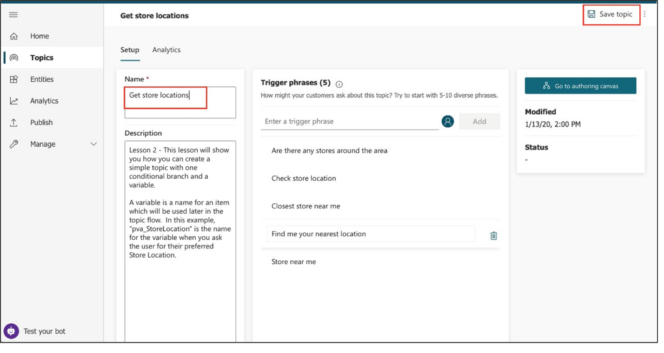](https://docs.microsoft.com/en-us/learn/modules/power-virtual-agents-bots/media/lab-11.png#lightbox)

1. Review the topic name and trigger phrases and click **Save topic** and follow the other steps in the Create custom topics for your bot article to complete the creation of your bot topic.

## Task 2: Create/Edit the topic

1. Select the name of the topic to open the topic or click **Go to authoring canvas** if you are already inside the topic.
2. Select the current text in the **Name** field, delete it, and type to rename the topic to **Get store locations**.
3. Select **Save topic** in the upper right corner of the page.

[](https://docs.microsoft.com/en-us/learn/modules/power-virtual-agents-bots/media/lab-11.png#lightbox)

1. Let's imagine you opened a new store in Bellevue. To add the store info to your bot, you need to edit the topic design in the authoring canvas. Select **Go to authoring canvas**.

The authoring canvas contains all the text and logic for the conversation about store locations. At the top, you'll see a reminder of the trigger phrases, which are added and edited on the **Setup** page.

[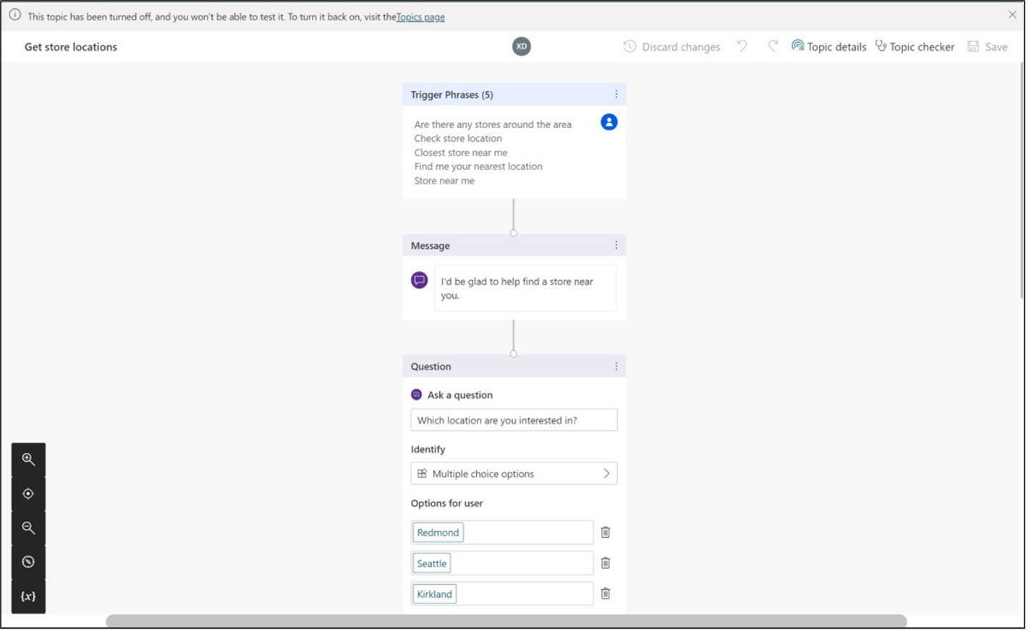](https://docs.microsoft.com/en-us/learn/modules/power-virtual-agents-bots/media/lab-12.png#lightbox)

1. Scroll down the page to see the conversation design.

Each of the connected boxes you see is called a "node." You can see that the bot displays a message in a **Message** node that it's happy to help find a store location and then asks in a **Question** node which location the user is interested in. (You can reopen the test bot to see that this is the same as the conversation you had in Exercise 2. Then close the test bot again.)

1. Scroll to the Question node that asks "Which location are you interested in?". We're going to add another option here.
2. Under "Redmond" "Seattle" "Kirkland," select **+ New option**.

[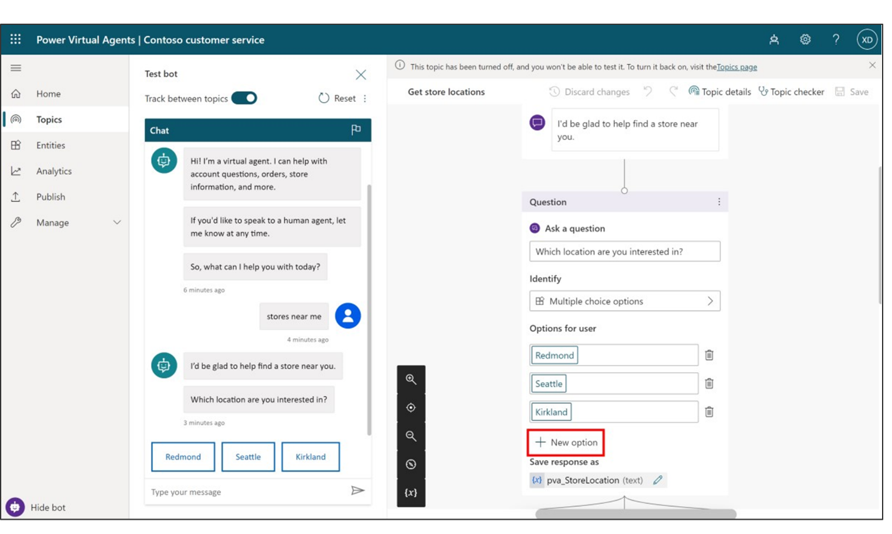](https://docs.microsoft.com/en-us/learn/modules/power-virtual-agents-bots/media/lab-13.png#lightbox)

A new **Condition** node is added under the Question node.

[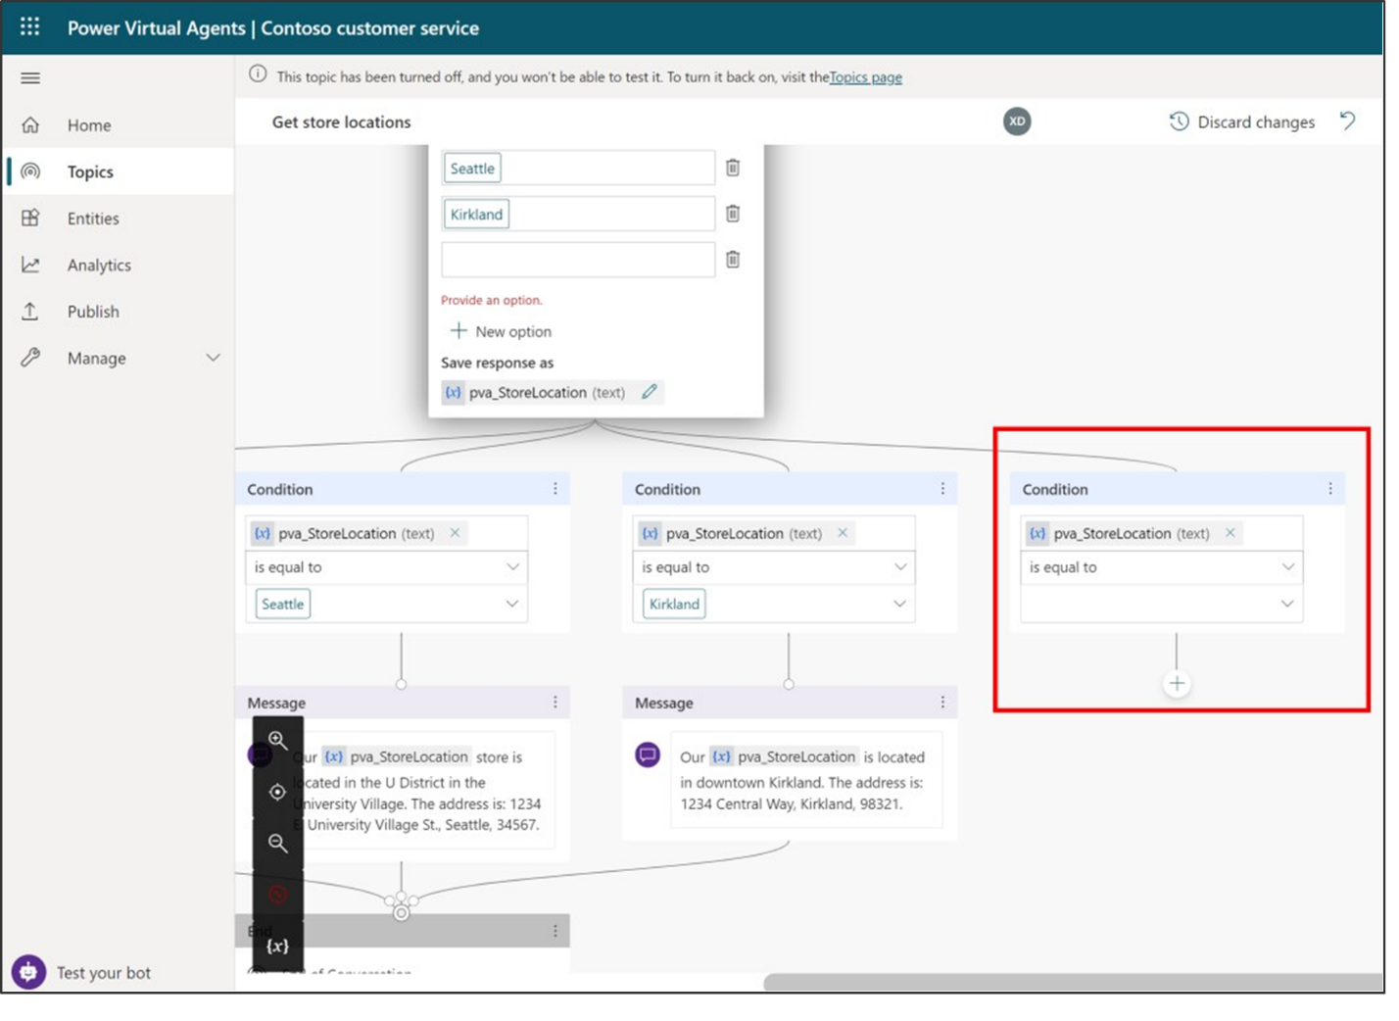](https://docs.microsoft.com/en-us/learn/modules/power-virtual-agents-bots/media/lab-14.png#lightbox)

1. In the Question node (**NOT** in the Condition node), type **Bellevue** in the newly added empty box under **Options for user**.

**Bellevue** is automatically added for you in the Condition node too.

[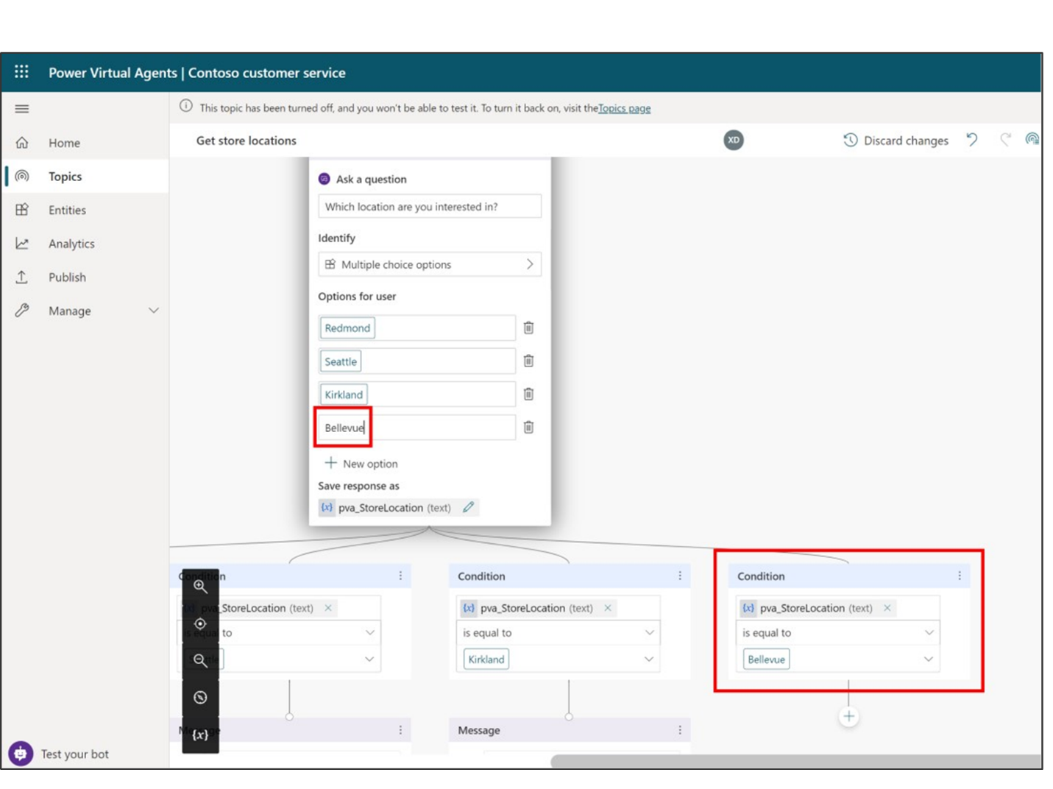](https://docs.microsoft.com/en-us/learn/modules/power-virtual-agents-bots/media/lab-15.png#lightbox)

**Note**

The **Options for user** section controls what buttons are visible to users in the chat window, and always need to be matched with a condition, or the button won't work. The Conditions, however, can handle the user typing something that is not shown in a button. So for instance if you were to delete the Bellevue **Options for user** button, it would not delete the Bellevue Condition node, which would be used if the user types "Bellevue" when asked for a location.

Now, you'll tell the bot what message to display if the user selects **Bellevue**. The new condition node looks like this:

[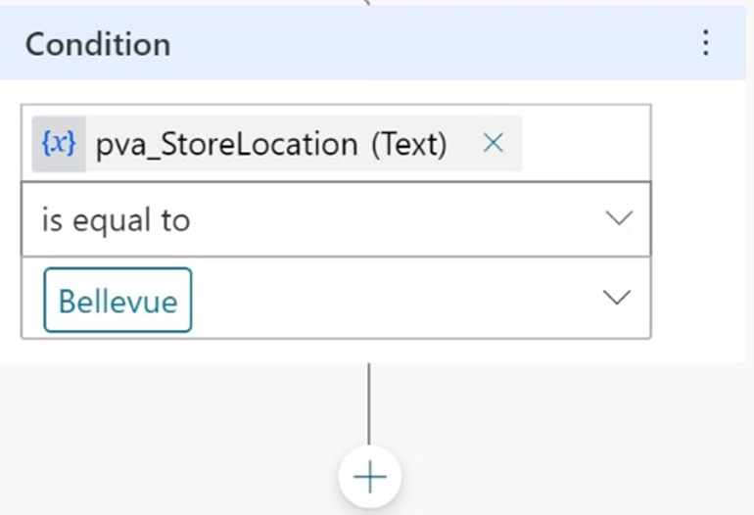](https://docs.microsoft.com/en-us/learn/modules/power-virtual-agents-bots/media/lab-16.png#lightbox)

1. From the options that appear, select **Show a message**.

[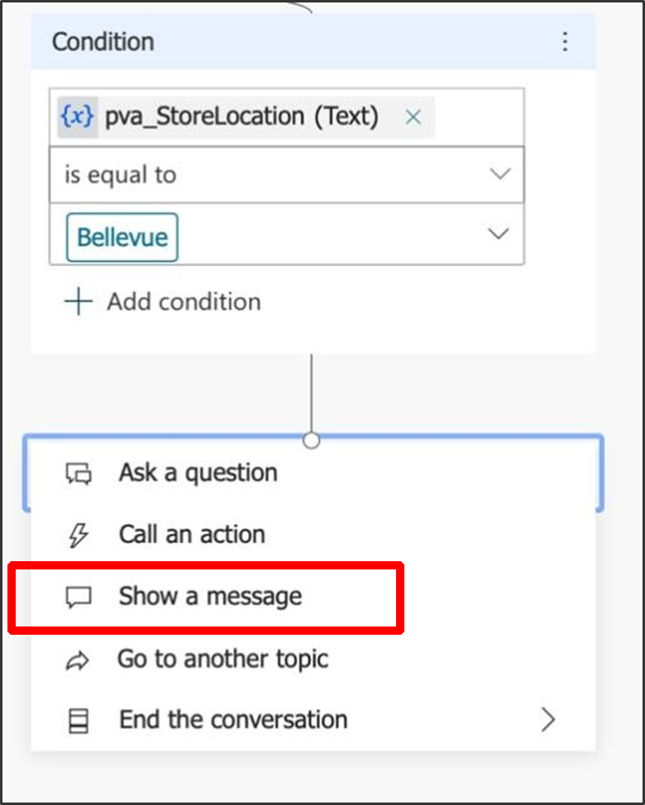](https://docs.microsoft.com/en-us/learn/modules/power-virtual-agents-bots/media/lab-17.png#lightbox)

This adds a new Message node connected to the Bellevue condition.

1. In the Message node, enter the store location info: **Our Bellevue store is in 1234 Bellevue Way, Bellevue, WA 98123.**

[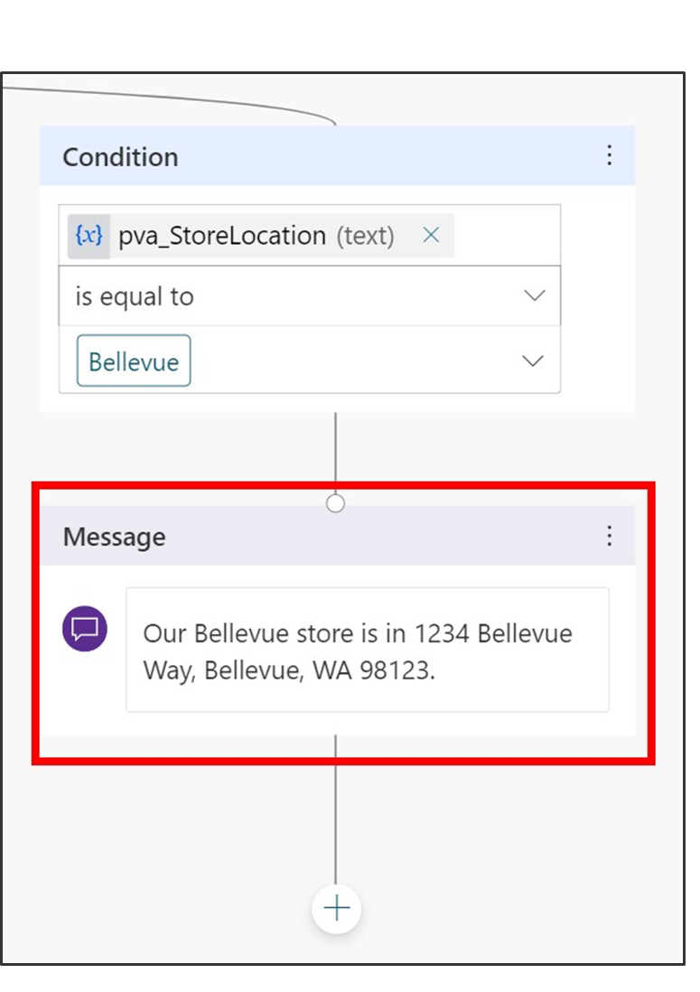](https://docs.microsoft.com/en-us/learn/modules/power-virtual-agents-bots/media/lab-18.png#lightbox)

**Note**

You can format the message text using the formatting buttons that appear while you're typing. You can even replace the name of the location with the value of the pva_StoreLocation variable by using the {x} control.

You are now going to end the conversation. Since the conversation ends the same way no matter which location the user chose, we're going to link to a shared **End of conversation** node. This node starts the **End of conversation** system topic.

1. First, zoom out if necessary to see the **End of conversation** node on your screen. (**Zoom out** is in the utility bar on the left of the authoring canvas.)

[](https://docs.microsoft.com/en-us/learn/modules/power-virtual-agents-bots/media/lab-19.png#lightbox)

1. Select the **Add node** button below the Bellevue location Message node.

[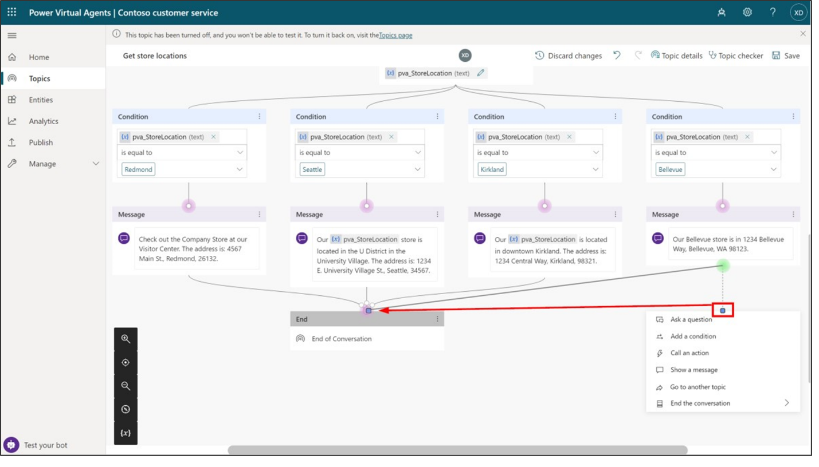](https://docs.microsoft.com/en-us/learn/modules/power-virtual-agents-bots/media/lab-20.png#lightbox)

1. When the list of options appears, instead of selecting an option, hover your mouse over the connector dot at the top, which will turn pink. Then select the dot and drag the connector to the left until you connect with the top of the **End of conversation** node (which is already connected to the other three location messages).

[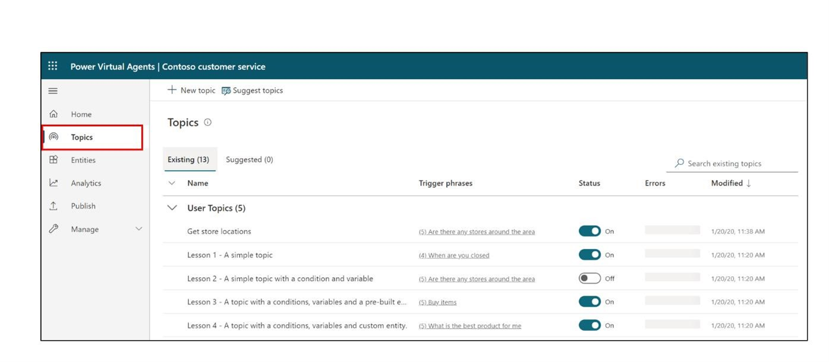](https://docs.microsoft.com/en-us/learn/modules/power-virtual-agents-bots/media/lab-21.png#lightbox)

1. At the top right of the page, select **Save** to save the changes you made.

## Task 3: Turn on your topic and test your changes

You may recall that when we made a copy of the Lesson 2 topic, the copy was created in an Off state. This means you can't trigger the topic in the test bot (and if you published your bot, your users couldn't trigger it either). We're ready to turn on the edited topic now.

1. Select the **Topics** tab in the left navigation to return to the Topics list.

[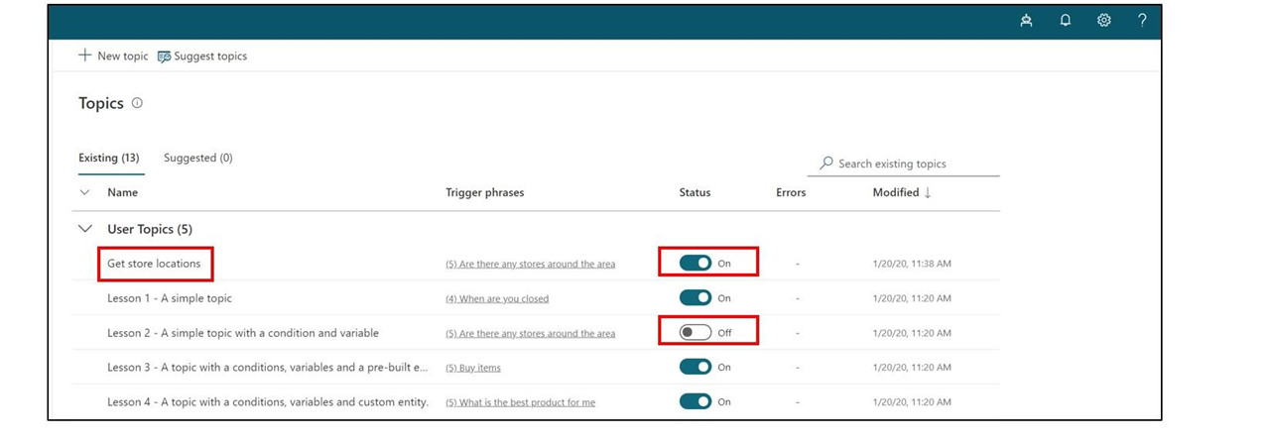](https://docs.microsoft.com/en-us/learn/modules/power-virtual-agents-bots/media/lab-22.png#lightbox)

1. Select the **Status** toggle from On to **Off** for **Lesson 2 - A simple topic with a condition and variable** and select the **Status** toggle from Off to **On** for **Get store locations.** Now, you can test the conversation you edited.

[](https://docs.microsoft.com/en-us/learn/modules/power-virtual-agents-bots/media/lab-23.png#lightbox)

1. In the bottom-left corner of the page, select **Test your bot**. Make sure the **Track between topics** toggle is set to the **On** position. In the test bot, enter **Is there a store near me?** and select the **Send** button.

[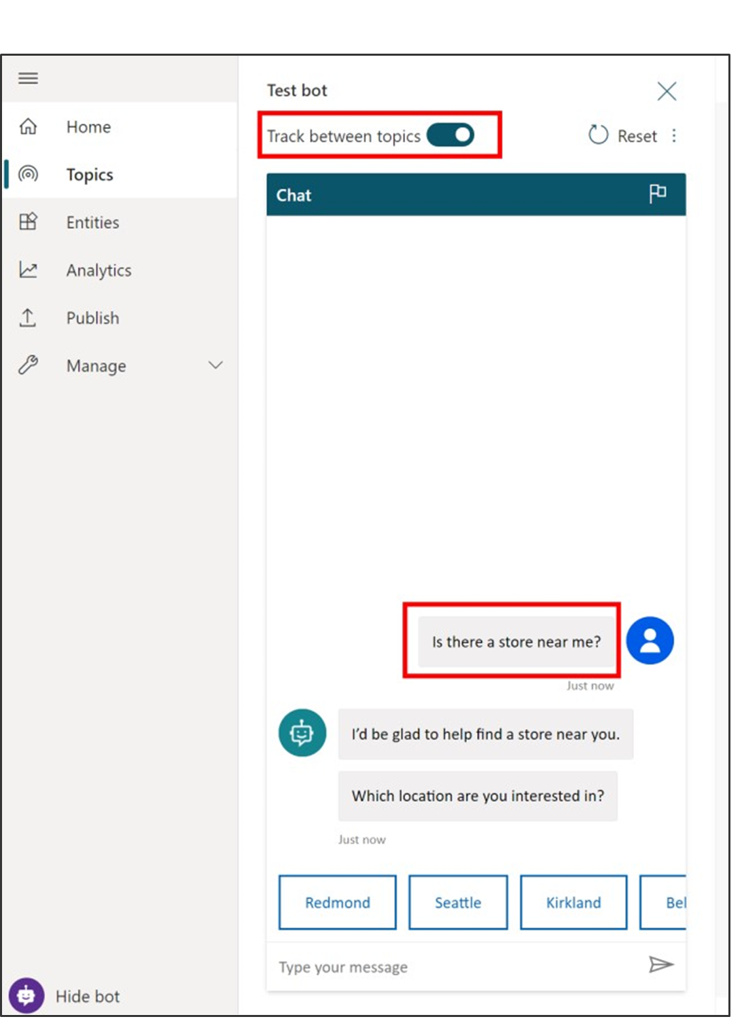](https://docs.microsoft.com/en-us/learn/modules/power-virtual-agents-bots/media/lab-24.png#lightbox)

Notice that even though it isn't exactly the same as the trigger phrases in the topic, "Is there a store near me?" works to trigger the topic because Power Virtual Agents understands that it means the same thing as the trigger phrases.

1. When asked to select a location, select the **Bellevue** location in the test chat. (You might need to use the onscreen right arrow to see the Bellevue option. If you don't see the option at all, make sure you did steps 1, 2, and 3 of this task.)

[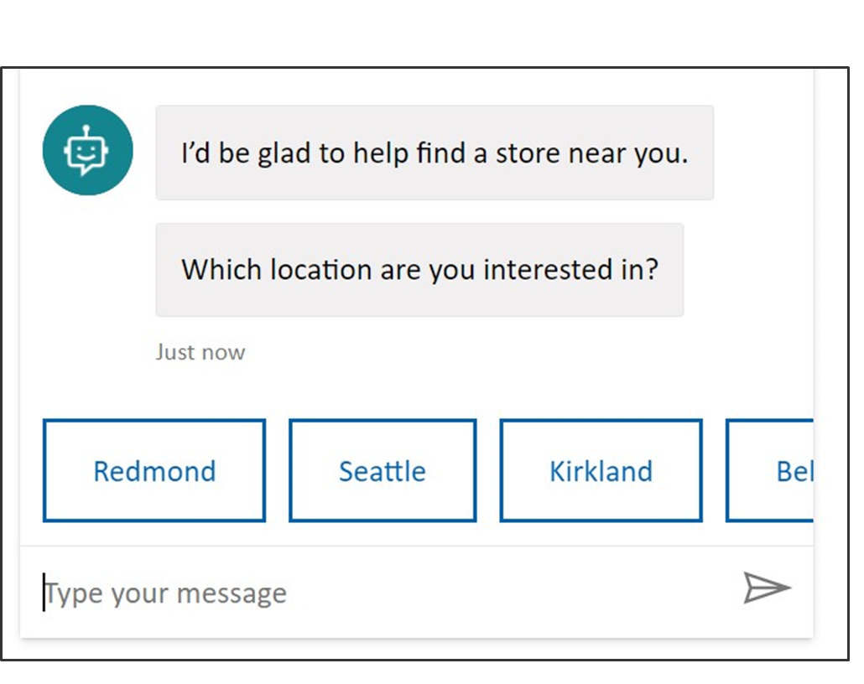](https://docs.microsoft.com/en-us/learn/modules/power-virtual-agents-bots/media/lab-25.png#lightbox)

[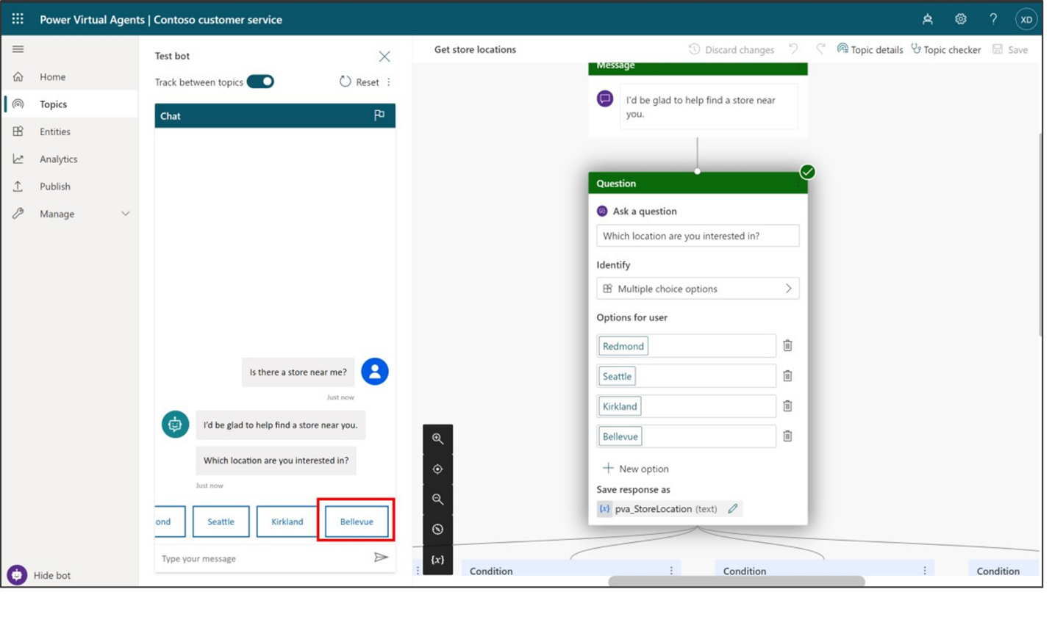](https://docs.microsoft.com/en-us/learn/modules/power-virtual-agents-bots/media/lab-26.png#lightbox)

The bot replies with location info for Bellevue store. Notice that the conversation continues in the **End of conversation** system topic. Feel free to keep chatting with the test bot.

## Task 4: Publish your bot to the demo site for testing

Power Virtual Agents provides a demo website so that you can invite anyone to test your bot by sending them the URL. This demo website is useful to gather feedback to improve the bot content before you activate the bot for your real customers.

1. Go to the **Publish** tab on the left navigation pane.
2. Select **Publish** to push the latest bot topics to the demo website. You will need to do this before you use the demo site the first time and also after you make changes to the bot topics that you want people to test on the demo website. (When you've created your real chatbot, you will Publish each time you want to make updated topics available to your customers.)

[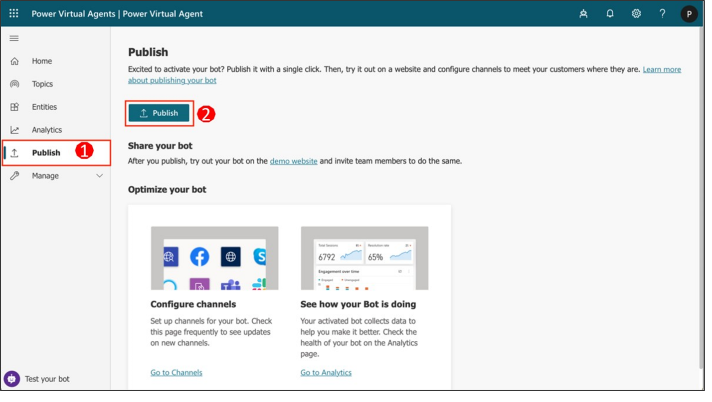](https://docs.microsoft.com/en-us/learn/modules/power-virtual-agents-bots/media/lab-27.png#lightbox)

The publishing process will check for errors in the bot topics whose Status is On. Publication should take only a few minutes.

You will see a message at the top of the screen when publishing is complete.

1. Select the link for the **demo website**.

[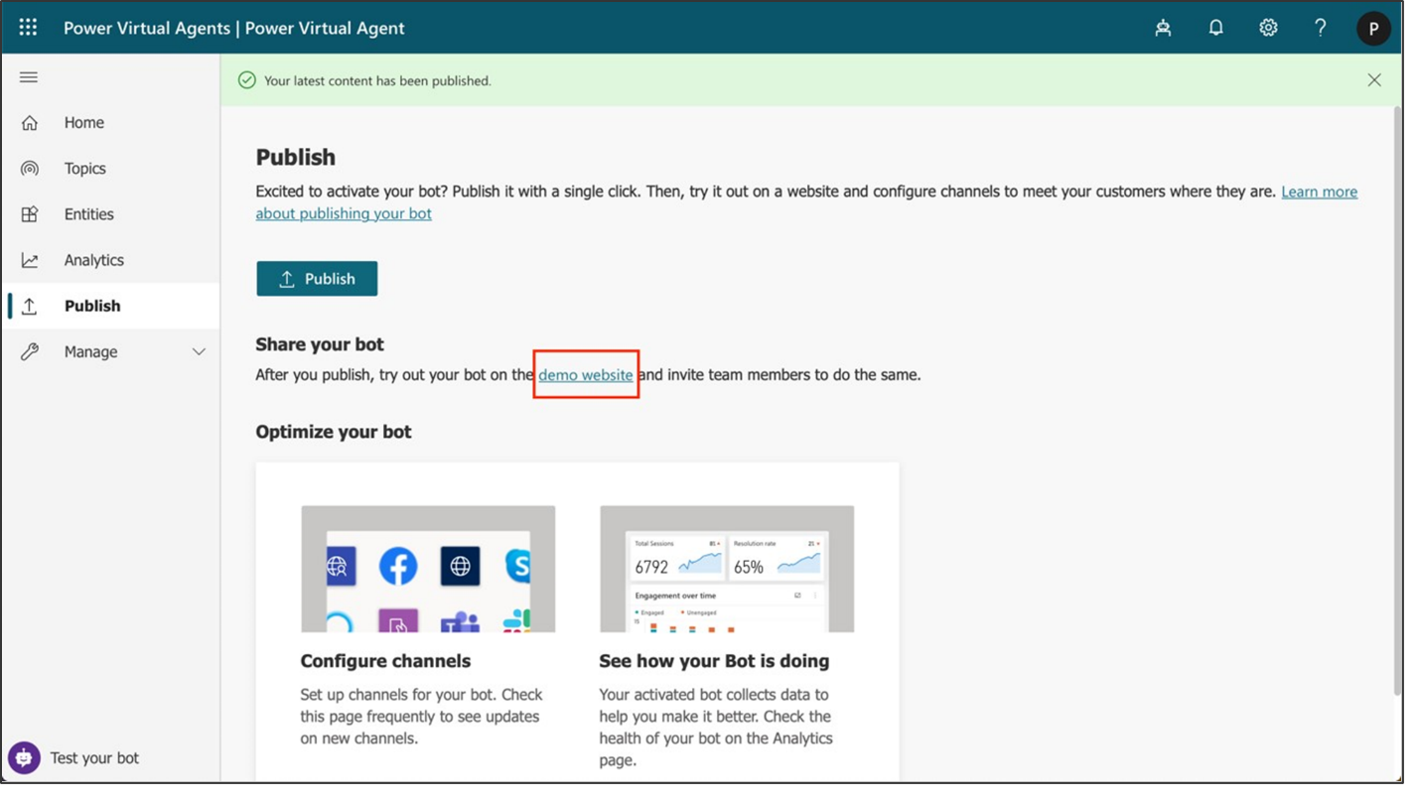](https://docs.microsoft.com/en-us/learn/modules/power-virtual-agents-bots/media/lab-28.png#lightbox)

1. When the demo site window opens, you can interact with the bot canvas by typing at the **Type your message** prompt or by selecting a starter phrase from the provided options.

[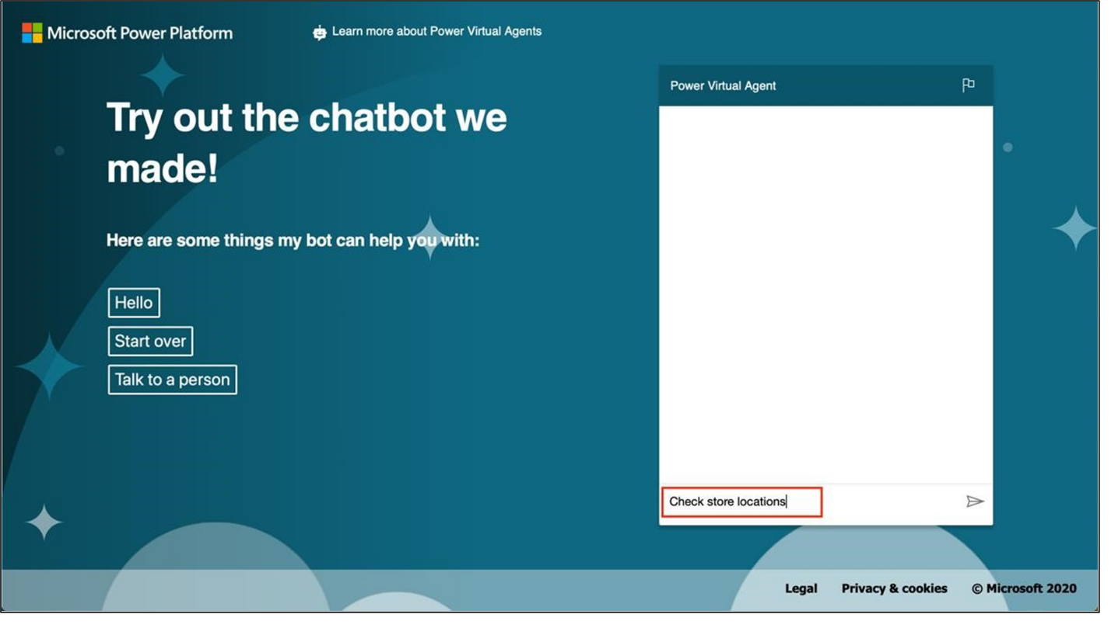](https://docs.microsoft.com/en-us/learn/modules/power-virtual-agents-bots/media/lab-29.png#lightbox)

1. You can share the URL of the **demo website** with your team.

# Exercise 2: Create survey and send it to customer after case completed

## Task 1: Create New Survey

To create a new survey, follow these steps:

1. Go to [Dynamics 365 Customer Voice](https://customervoice.microsoft.com/) and sign in with your credentials.
2. Select **All Projects** from the navigation menu.

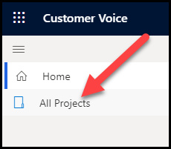

1. Select New Project. Choose Support as template and click Next.

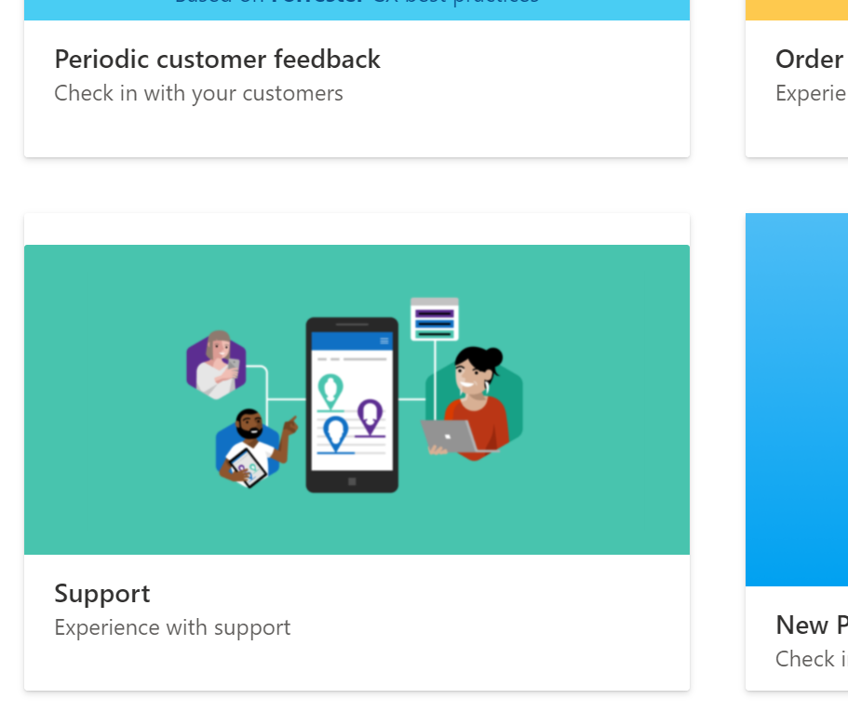

1. Choose your environment for Survey location and click **Select and close** and **Create.**

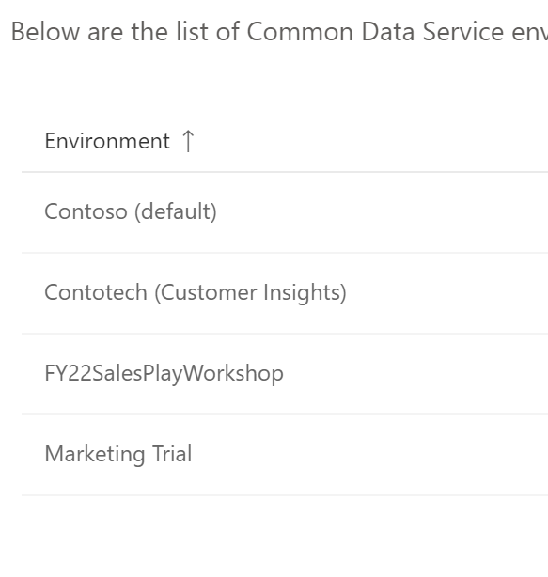

1. The project will open, and the existing default survey for that project will be displayed. Select **New survey**.

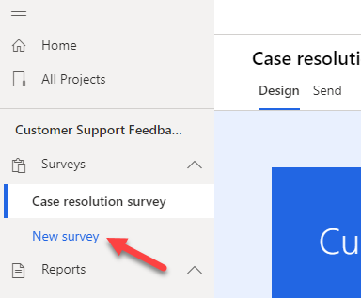

1. After the survey has been created, select the ellipsis (**...**) next to the new survey and then select **Rename**.

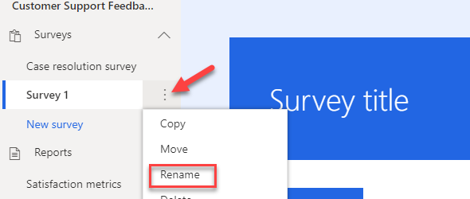

1. Enter **Premium Support Survey** as the new name and then select **Rename**.

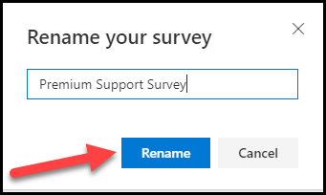

1. Select the **New Survey** title.

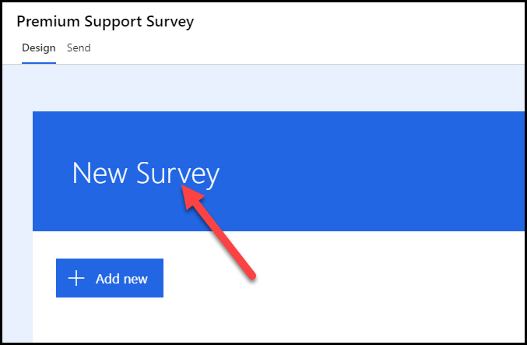

1. Enter **Case Resolution Survey** as a **Title**.
2. Select **+ Add new**.

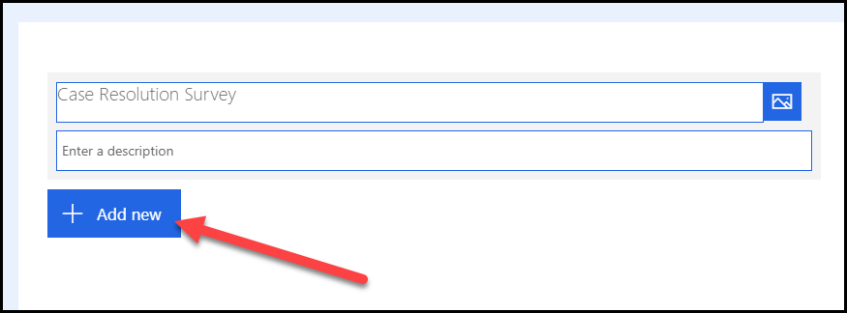

1. Select the **More** button.

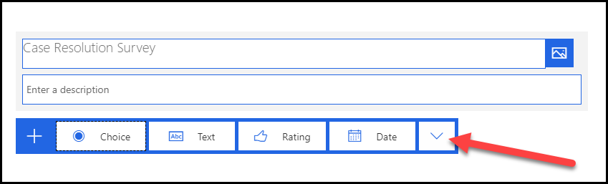

1. You should see all survey question types that are available to you. Select **Rating**.

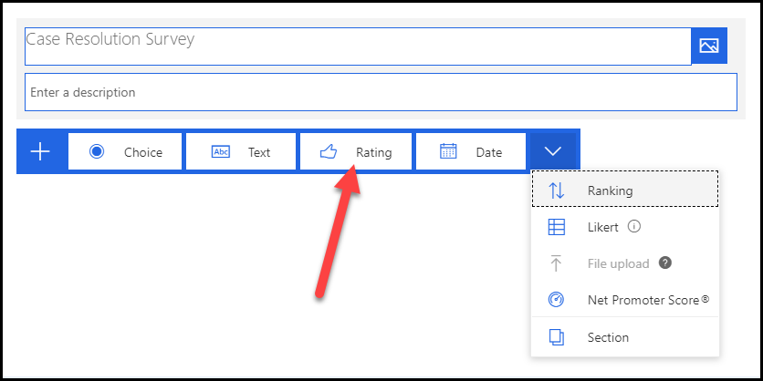

1. Enter **Overall, how happy were you with how your case was handled?** for a question and then select **Smiley** for the **Symbol**.

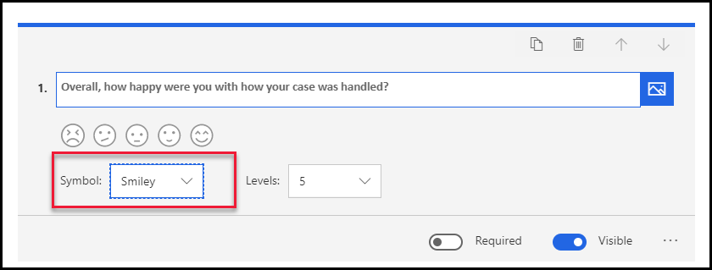

1. Select **+ Add new** again.
2. Select the **More** button and then select **Likert**.

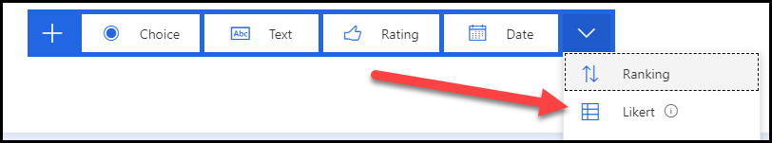

1. Enter **Do you agree or disagree with the following statements:** for a question and then change **Option 1** to **Strongly disagree**.

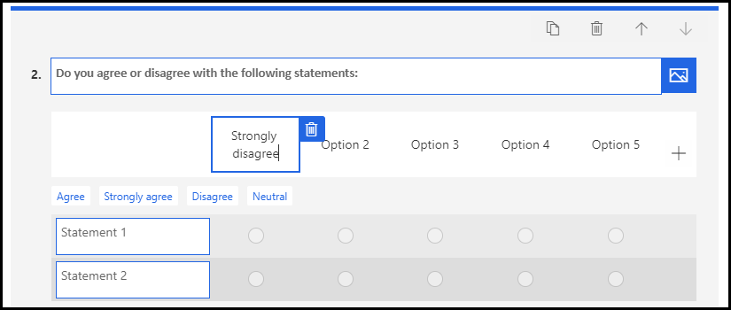

1. Replace **Option 2** with **Somewhat disagree**, **Option 3** with **Neither agree nor disagree**, **Option 4** with **Somewhat agree**, and **Option 5** with **Strongly agree**. Your options should now look like the following image.

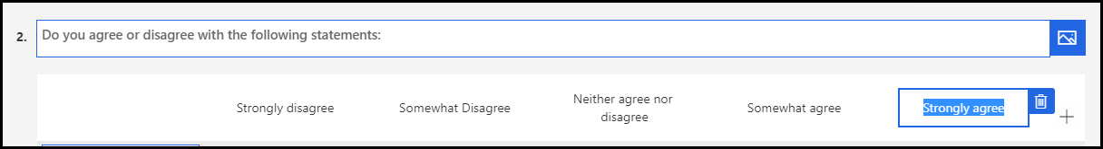

1. Select **Statement 1** and enter **The support rep was knowledgeable**.
2. Select **Statement 2** and enter **The case was responded to in a timely manner**.
3. Select **+ Add statement**.

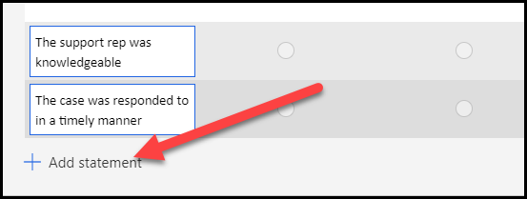

1. Enter **The support technician was courteous and helpful**.
2. Select **+ Add statement**.
3. Enter **I didn't have to wait more than 5 minutes to get call backs**.
4. Select **+ Add statement** one more time.
5. Enter **Contoso Inc. has excellent customer service**. Your statements should now look like the following image.

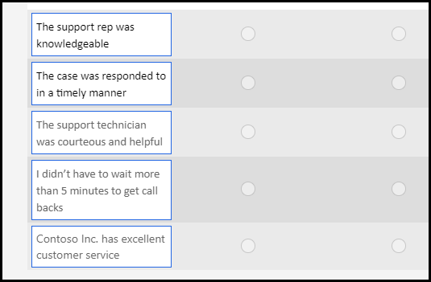

1. Select **+ Add new**.
2. Select **Text**.
3. Enter **Please tell us about your experience with our support team** for a question and select **Long answer**.

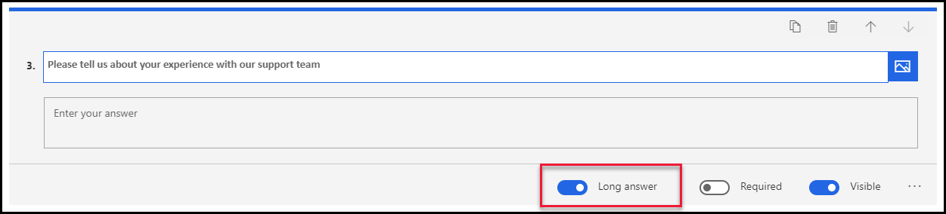

1. Select **+ Add new** again.
2. Select the **More** button and then select **Net Promoter Score**.

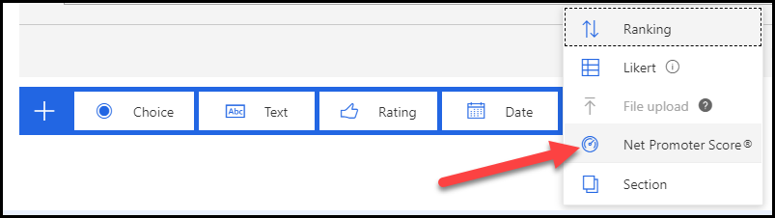

1. Enter **How satisfied were you with our case resolution process?** for a question.
2. Change the lowest rating to **Not satisfied at all** and the highest to **Very satisfied**.

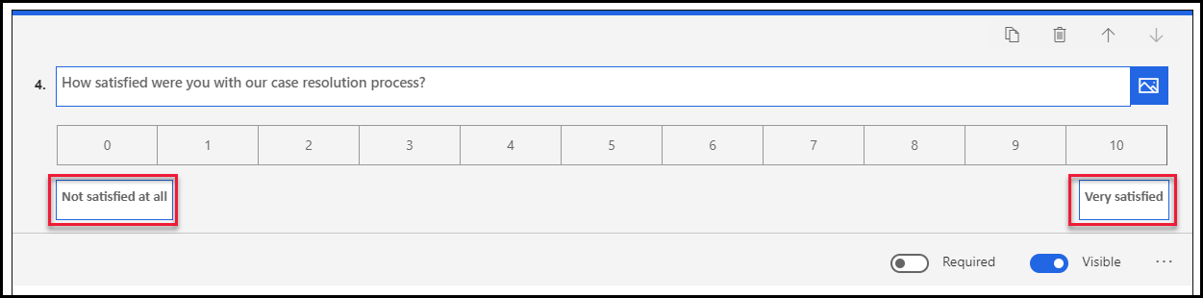

1. Select **Preview**.

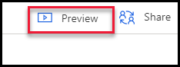

1. Review your survey and then select the **Back** button. You may now close the form editor.

## Task 2: Test the survey

In this task, you will test your survey by sending it to yourself in an email message.

1. Select the **Send** tab from the top of your survey.

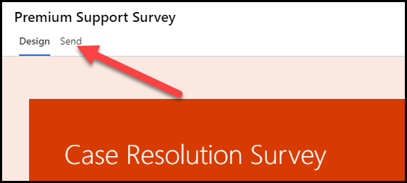

1. Select the **Customization** menu and then select **Distribution settings**.

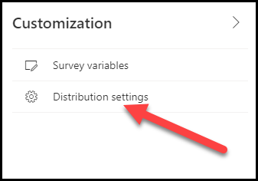

1. From the **Distribution settings** screen, select **Participants**.

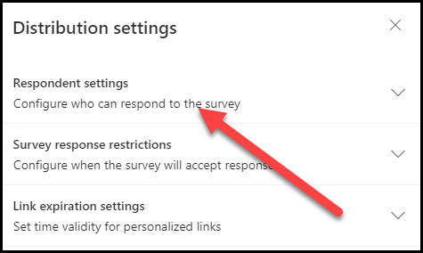

1. Make sure that the **Only people in my organization can respond** and the **Anonymize responses** settings are turned off.

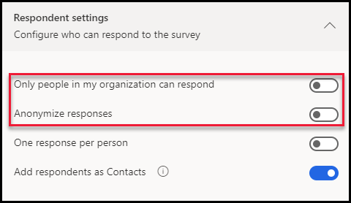

1. Select **Email** from the options on the **Send** tab.

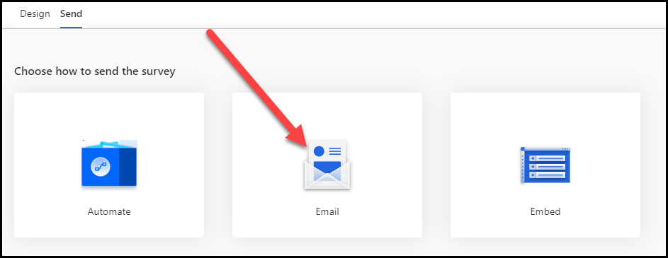

1. Provide your organization **Email Address** for **Recipients** and then select **Send**. The first name and last name of the user will only be available to your survey if at least one of the following statements is true for the email that you provided.
   1. It is a contact in Outlook.
   2. It is related to a record in your Dynamics environment.
   3. It is someone who is part of the same organization.

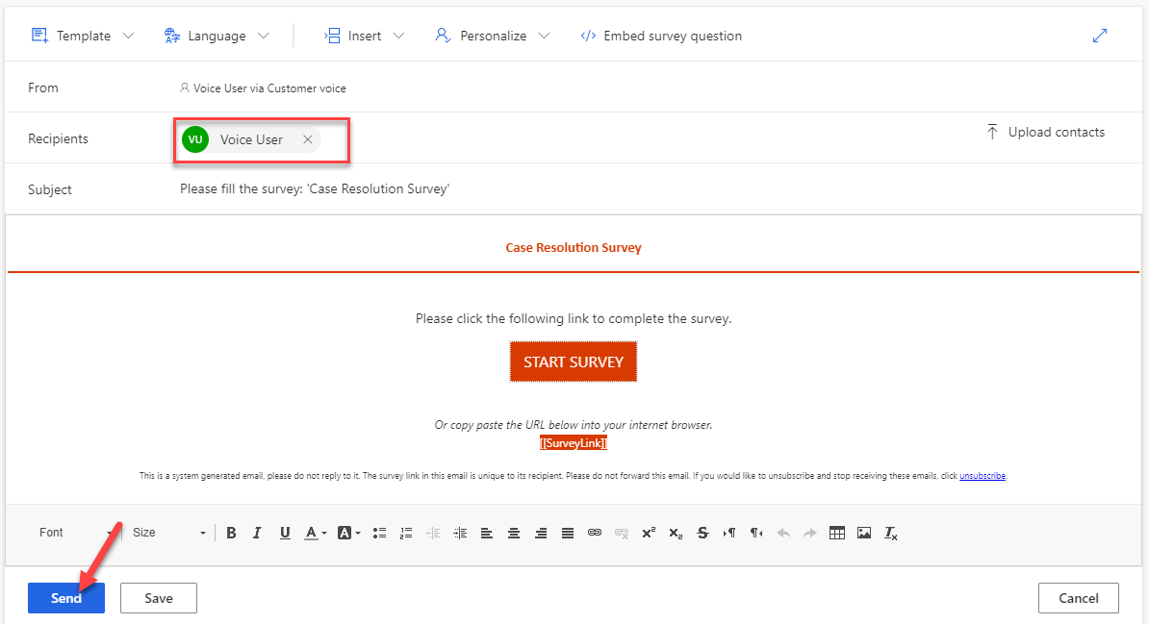

1. The survey will be sent.

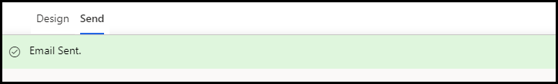

1. Go to your email, locate the survey email, and open it. Check your junk mail if you don't see it in your inbox.
2. Select **Start Survey**.



The survey should load, and your name should show in the description.

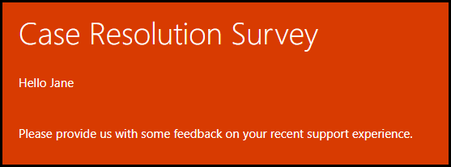

1. Provide a rating and answer the Likert questions.

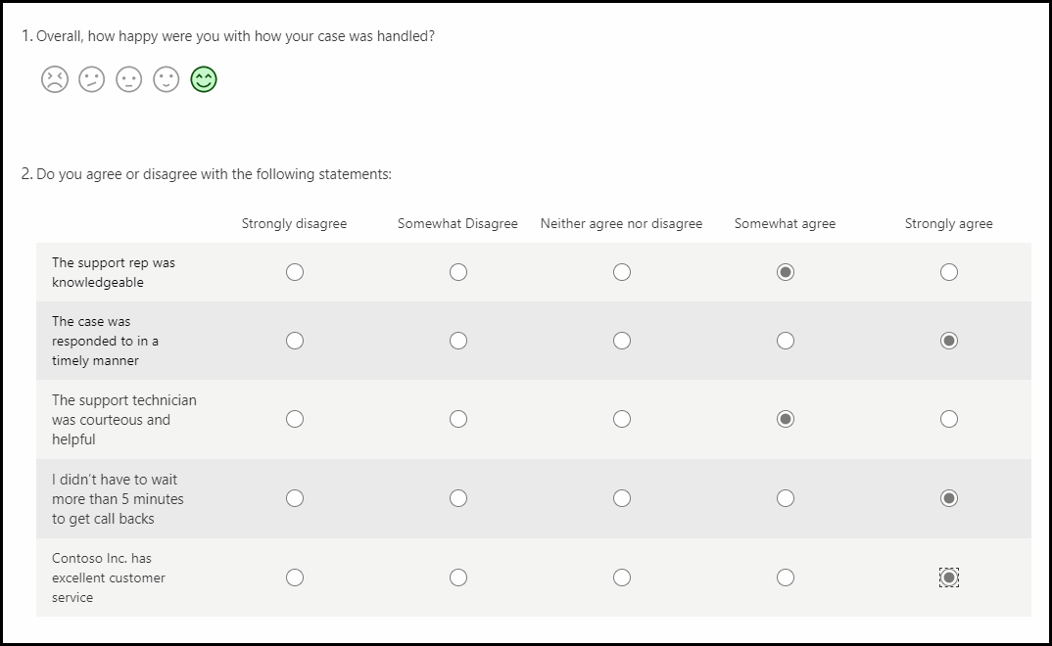

1. Provide a comment and select **7** for satisfaction. The last question should stay hidden.

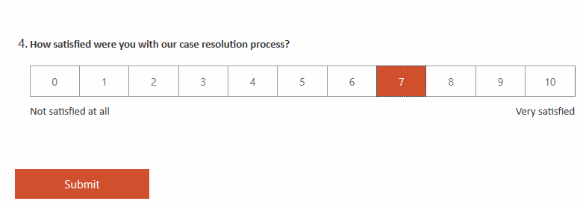

1. Change the satisfaction rating to **6**. The last question should now appear.

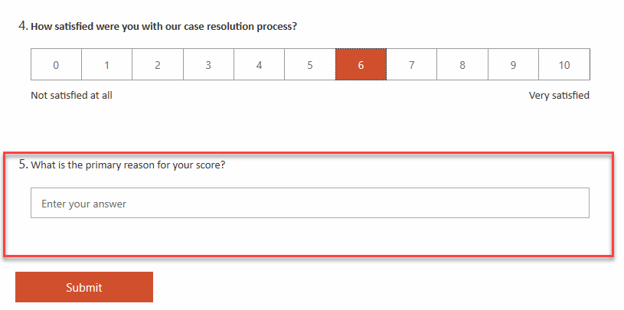

1. Change the rating to **8**. The last question should become hidden again.
2. Select **Submit**.

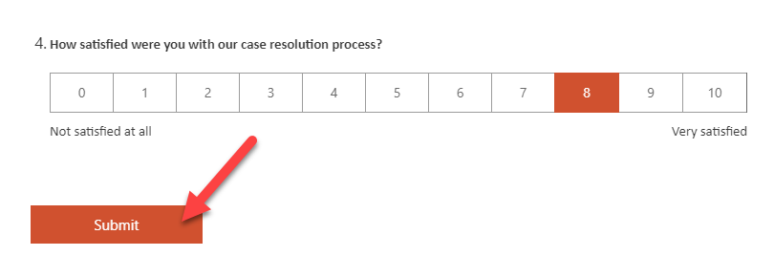

1. Wait for the survey submission to be completed.

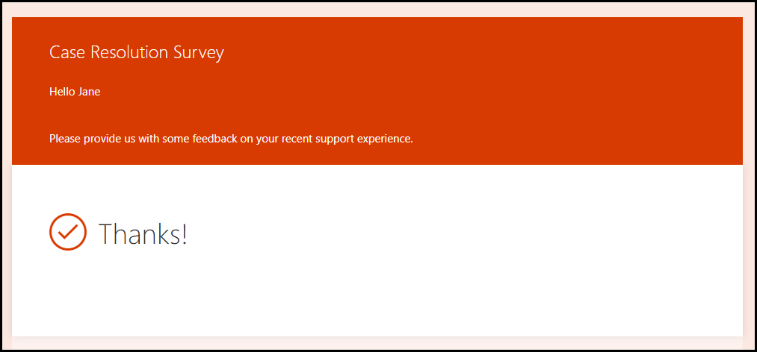

## Task 3: Select a Power Automate template

In this task, you will use Power Automate to send the survey that you created in the Work with Dynamics 365 Customer Voice projects module.

1. Go to [Customer Voice](https://customervoice.microsoft.com/) and sign in with your credentials.
2. Select the environment where you have Dynamics 365 Customer Engagement installed. The Dynamics 365 Customer Voice survey should have been created in the same environment.
3. Locate the Customer Support Feedback project that you created previously and select its name.

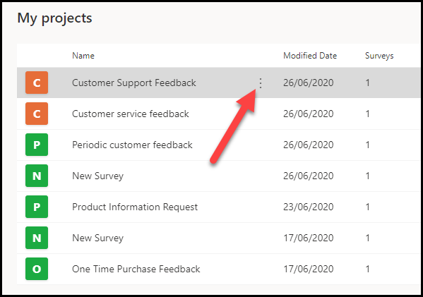

1. Select the **Premium Support Survey** that was created previously and then select the **Send** tab.

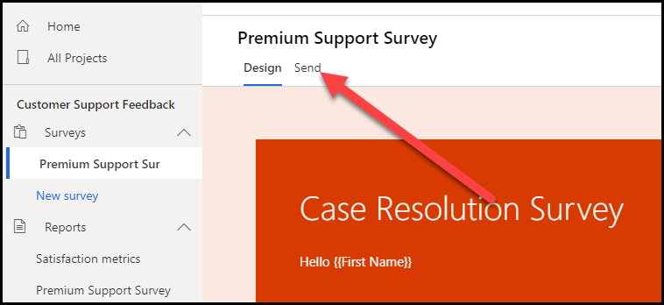

1. Select **Automate**.

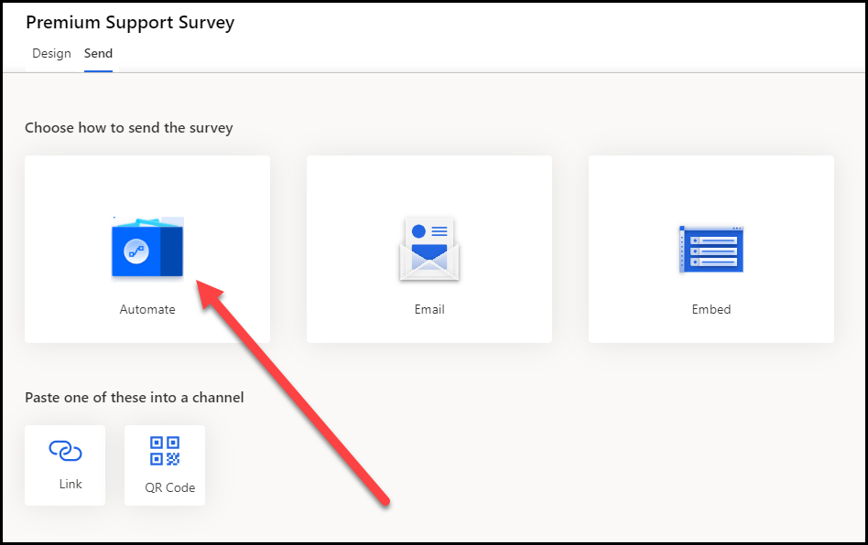

1. Select **Send a survey when a case is resolved in Dynamics 365**.

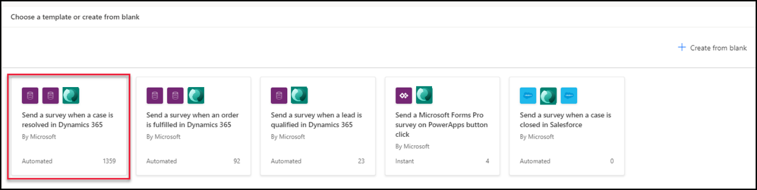

1. Follow the subsequent steps if this is your first time creating a flow. If you are not prompted to select a region, move on to the next step.

a. Select your **Country/Region** and then select **Get started**, if prompted.

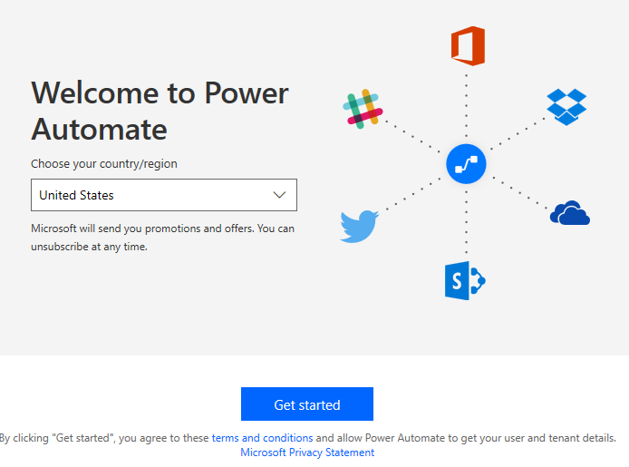

b. Select **Sign in** or **Update**, if prompted to sign in to your Microsoft Forms environment.

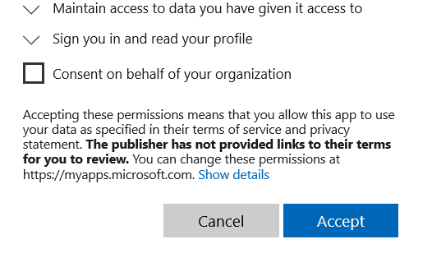

c. Select **Accept**.

d. Select **Continue**.

1. If you see the following screen (depending on if this is the first time you've signed in), select **Try it now**.

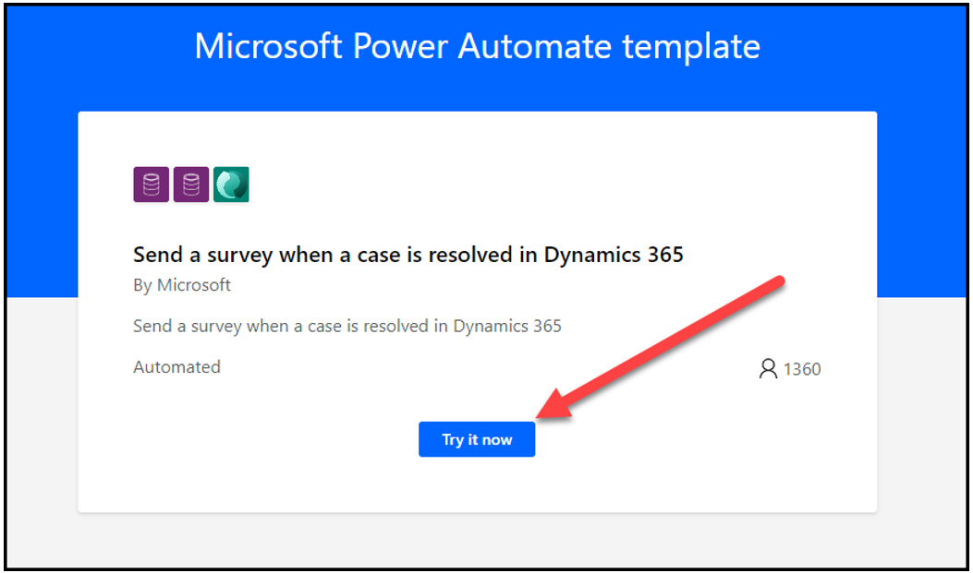

1. Select the environment where you have Dynamics 365 Customer Engagement installed and then select **Create**.

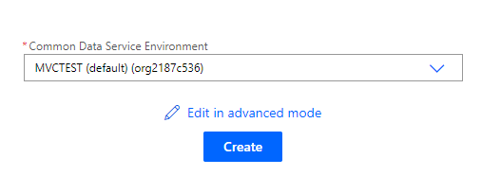

The flow will open in a new tab.

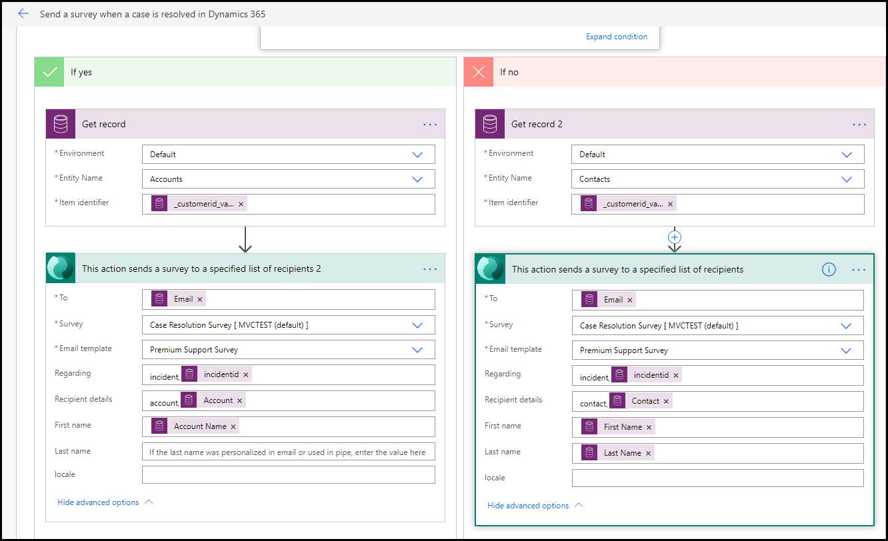

1. Do not navigate away from this page.

## Task 4: Examine and edit the flow

In this task, you will examine the flow that was created by the template and add a filter to the trigger. This filter will ensure that the flow is triggered only when the **Status Reason** column changes instead of running on every change that is made to the case record.

1. You should already be in edit mode for the flow that was created in Task 1. If not, and you are viewing the **Details** screen for the flow, select **Edit**.

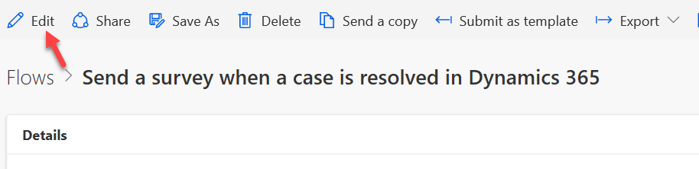

1. The flow should open in edit mode. Expand the trigger by selecting the header.

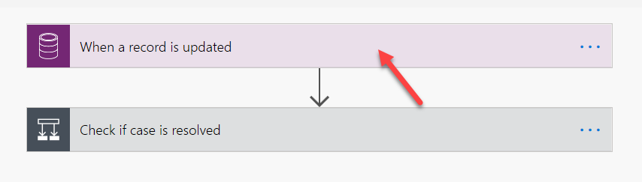

1. Select **Show advanced options**.

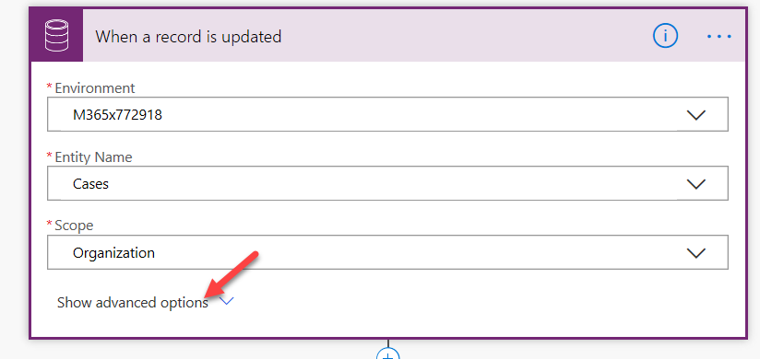

1. Select **status code** for **Attribute filter**. This action will make sure that the flow is triggered only when the status of the case changes.

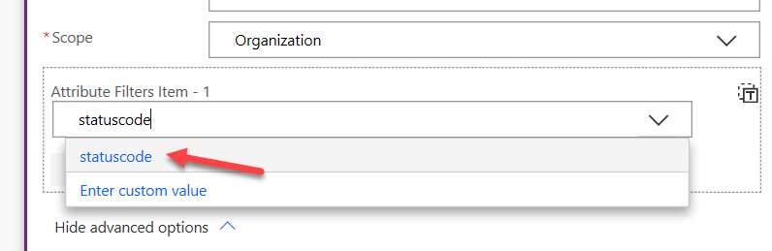

1. Select **Hide advanced options**.

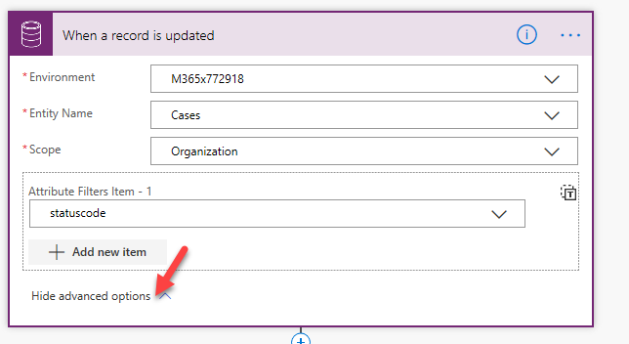

1. Collapse the trigger by selecting the header again.
2. Expand the condition.

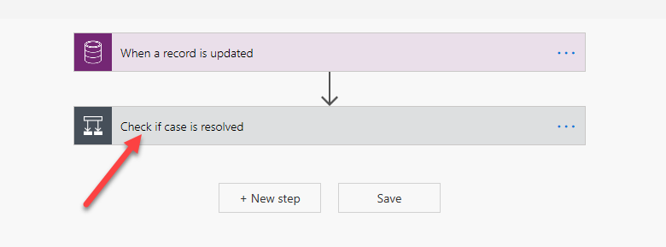

1. Select **Expand condition**.

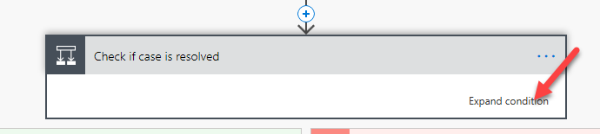

The first condition checks if the **Status Reason** value is **5** (Resolved).

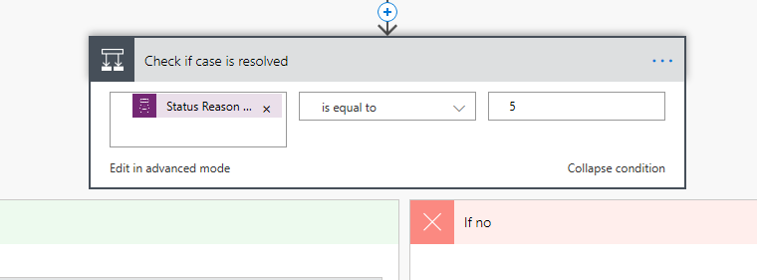

1. You will only take actions if the case was resolved. Expand the condition inside the **If yes** branch.

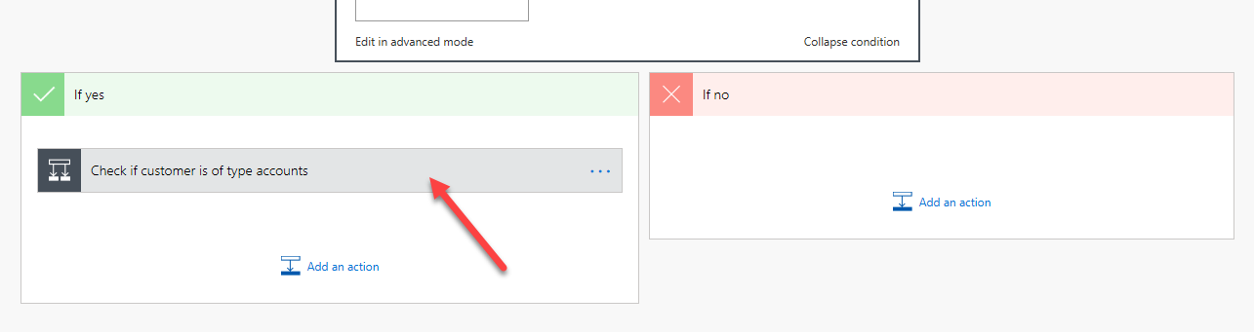

1. Select **Expand condition**.

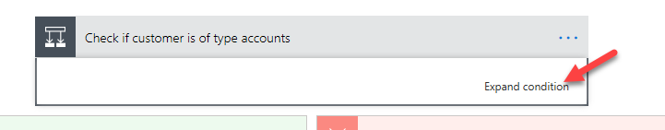

This condition checks if the customer type of the case is an account.

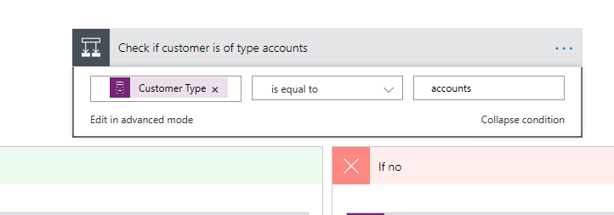

1. Evaluate both branches of the flow (you are not making changes, just viewing what has been created).

If the customer type of the case is an account:

* + The flow will get the account record.
  + Add the **Send survey** action.
  + Use the information from the prior actions to fill out the send survey columns.
  + Select the correct survey and email template.

If the customer type of the case is not an account:

* + The flow will get the contact record.
  + Add the **Send survey** action.
  + Use the information from the prior actions to fill out the send survey columns.
  + Select the correct survey and email template.



1. Collapse all actions and then select **Save**.

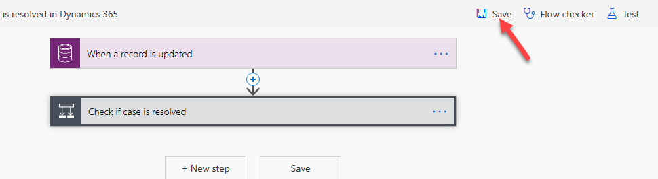

1. Do not navigate away from this page.

## Task 5: Test the flow

In this task, you will test the flow and see what the flow will send to the customer.

1. Start a new browser tab and navigate to your Dynamics 365 Sales Hub application.

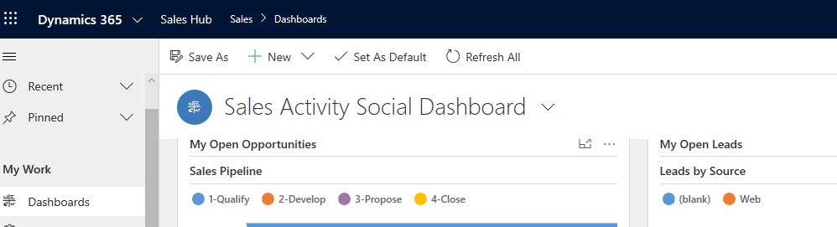

1. Select **Cases**.

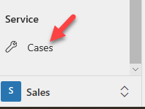

1. Select **+ New**.

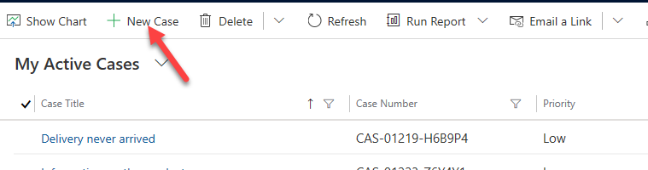

1. Enter **Missing parts** for **Case Title**, select the **Customer** column, and then select **+ New Record**.

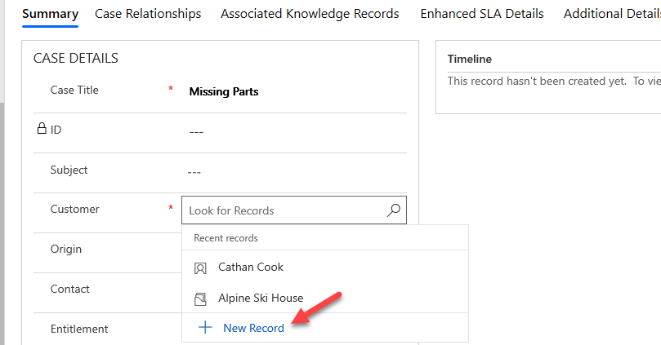

1. Select **Contacts**.

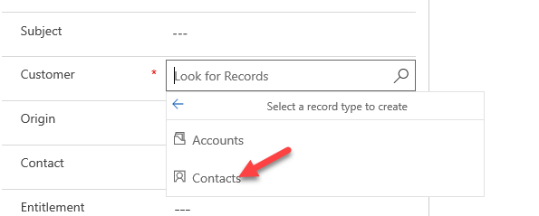

1. Provide the first name, last name, and your organization user's email.

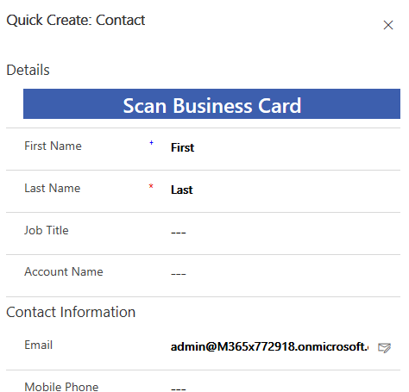

1. Select **Save and Close** to save the form.
2. Select **Save** to save the case record.

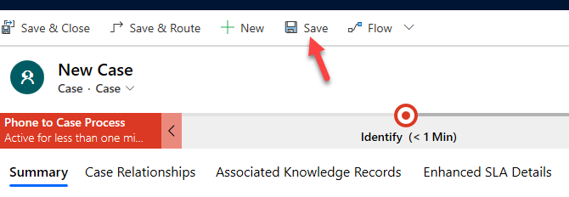

1. Select **Resolve Case**.

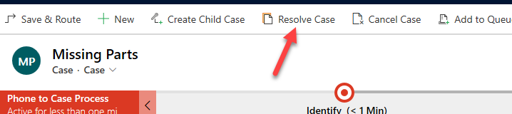

1. Enter **Sent replacement** for **Resolution**, select **15 minutes** for **Billable Time**, and then select **Resolve**.

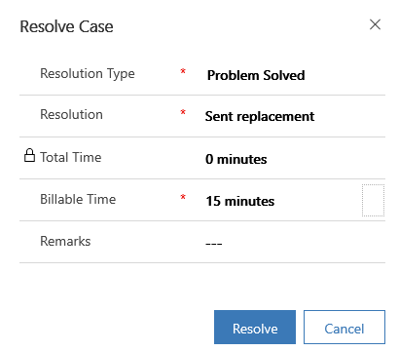

1. Go to Power Automate and select the back button.

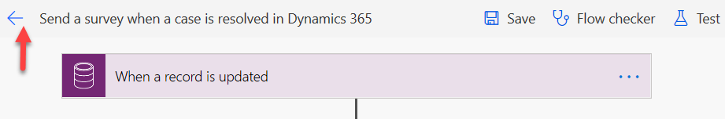

1. You should have at least one flow run, and it should have succeeded. Select to open the run.

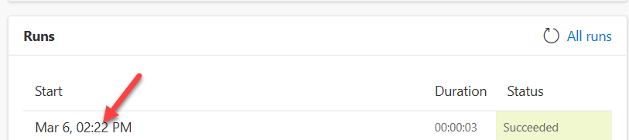

Your flow should take the **If no** path and run successfully.

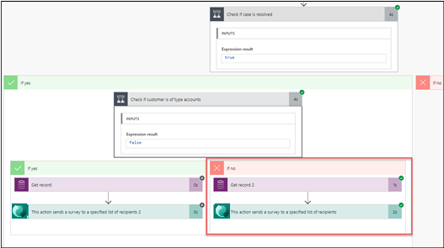

1. Start a new browser tab/window.
2. Go to [Outlook](https://outlook.com/) and sign in with your credentials.

You should receive an email similar to the following image.

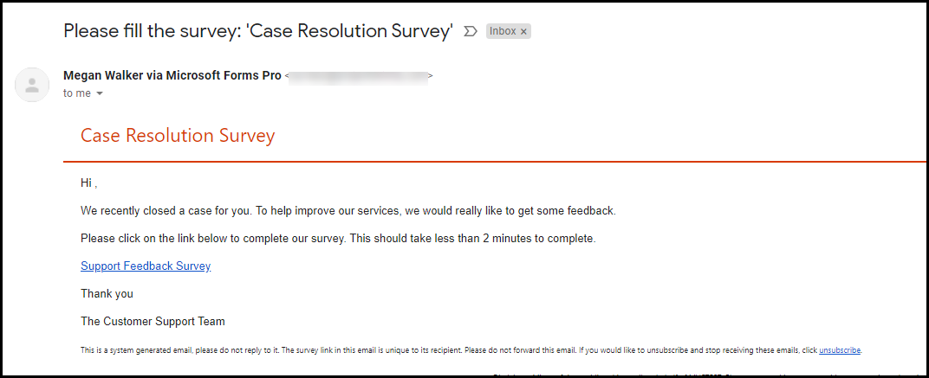

1. Select **Start Survey**.

The survey should open.

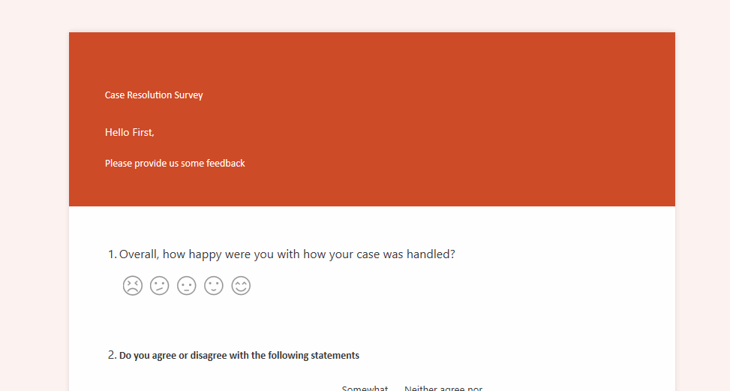

1. Close the survey browser window or tab.
2. Return to the case and select **Reactivate Case**.

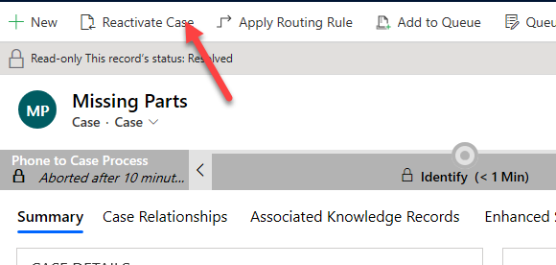

1. Select **Reactivate** to confirm.

## Task 6: Replace the Send survey action

In this task, you will delete the **Send survey** action that came with the Power Automate template and replace it with **Create invitation** action.

1. Return to the flow in Power Automate that was created in Task 1.
2. Select **Edit**.

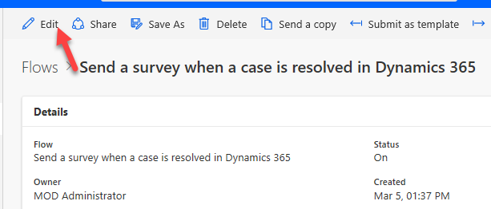

1. Expand the conditions and select the ellipsis (**...**) button of the **Send survey** action located in the **If no** branch.

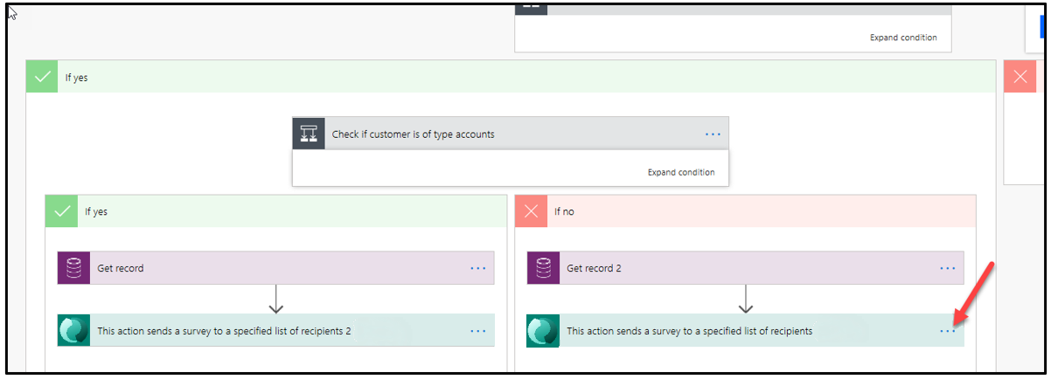

1. Select **Delete**.

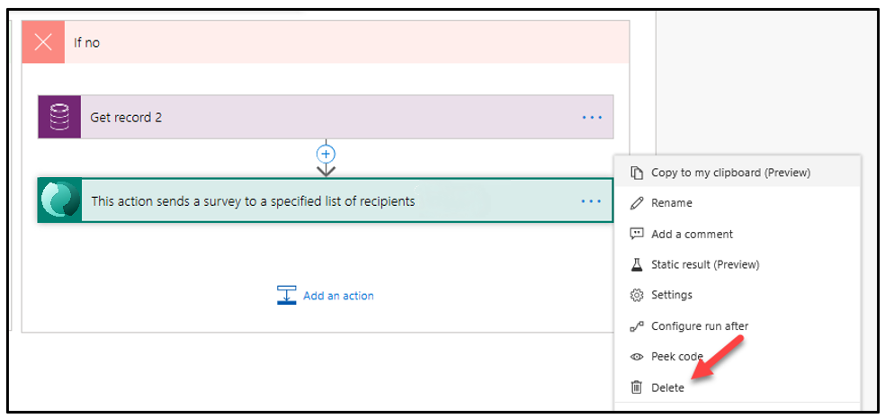

1. Select **OK**.
2. It is a good idea to name your flow actions. Select the ellipsis (**...**) button of **Get record 2** and then select **Rename**.

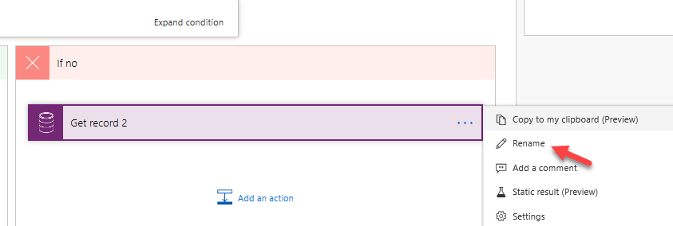

1. Rename the action **Get contact**.

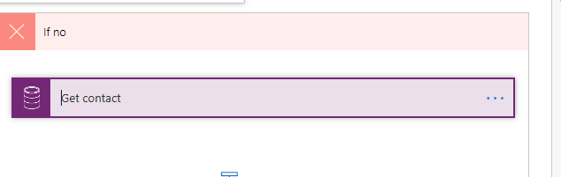

1. Select **Add an action**.

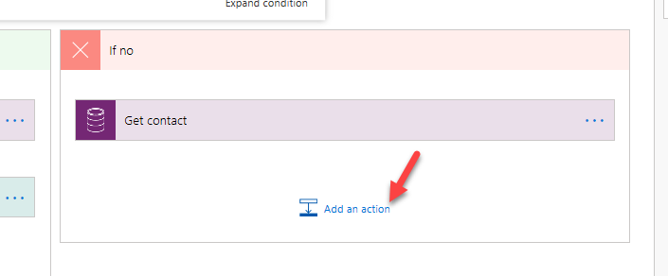

1. Search for **invitation** and select **Create an invitation**.
2. Rename the invitation **Create contact invitation**.

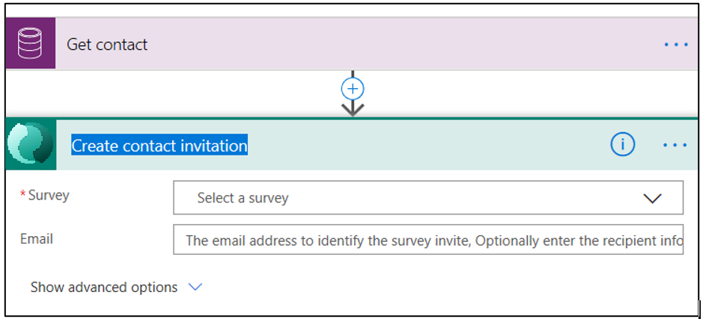

1. Select **Case Resolution Survey** for **Survey** and select the **Email** column.

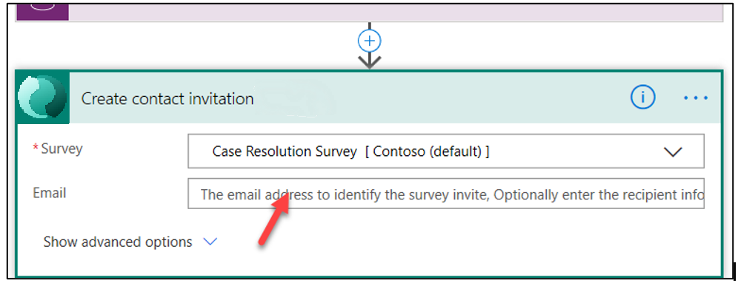

1. Search for **email** and select **Email** from the **Get contact** action.

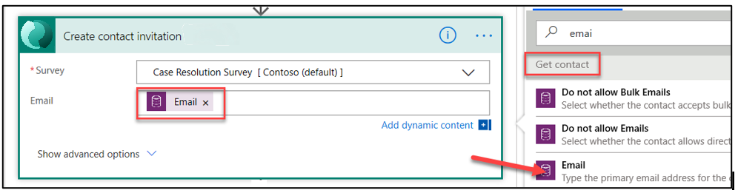

1. Select **Show advanced options**.

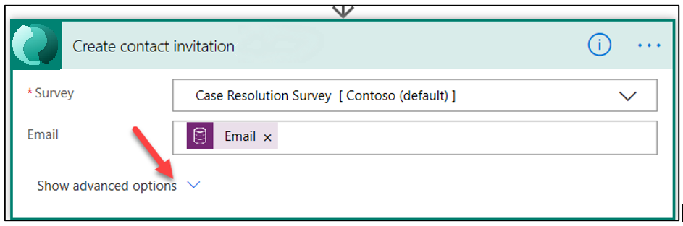

1. Select the **First Name** column and select **First Name** from the **Dynamic content** pane.

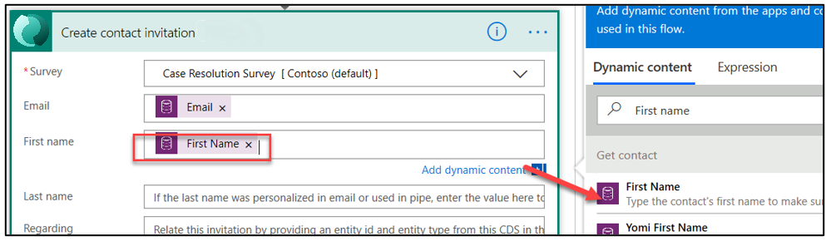

1. Select the **Last Name** column and select **Last Name** from the **Dynamic content** pane.

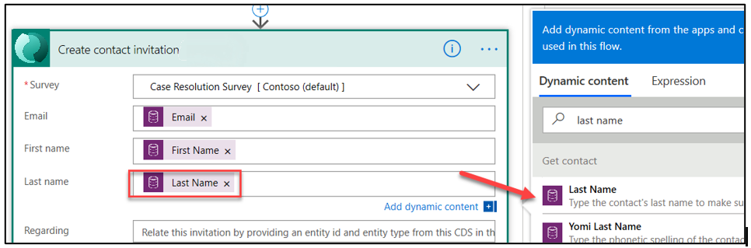

1. Type **Incident** in the **Regarding** column and select **Case** from the **Dynamic content** pane.

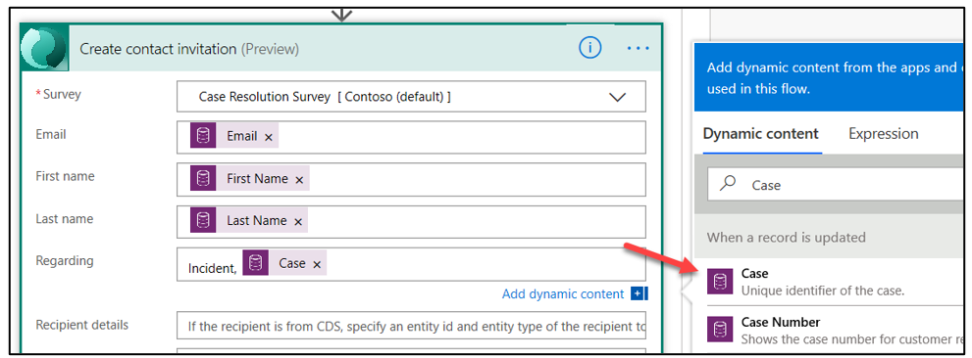

1. Type **Contact** in the **Recipient details** column and select **Contact** from the **Dynamic content** pane.

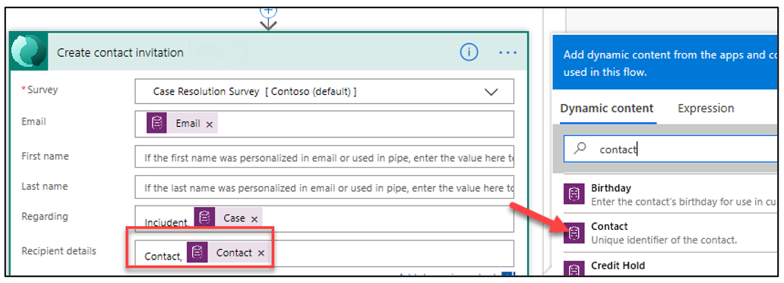

The invitation should now look like the following image.

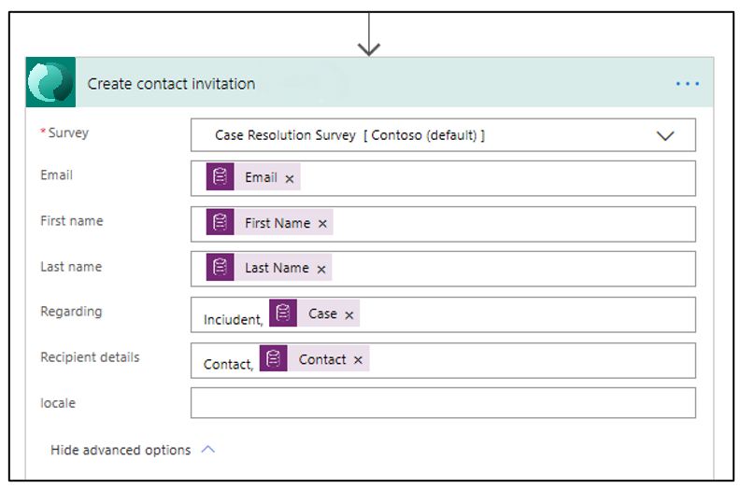

1. Save your progress by selecting the **Save** button.

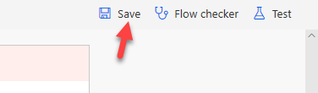

1. Do not navigate away from this page.

## Task 7: Send email

In this task, you will create a **Send email** action that will send the survey invitation.

1. Return to the **If no** path and select **Add an action**.

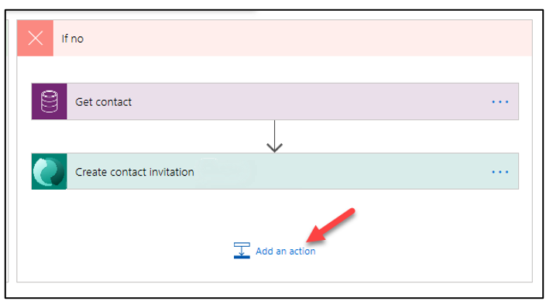

1. Search for **send an email** and select **Send an email (v2)**. If this is the first time that you have used this action, you might need to authenticate. If this connection doesn't work for you, check your user license.

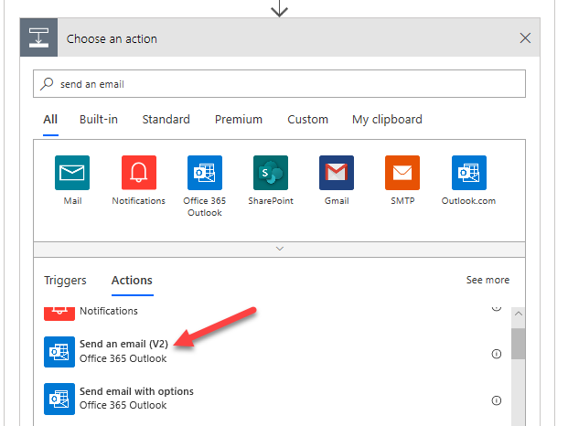

1. Rename the action **Send contact invitation**.

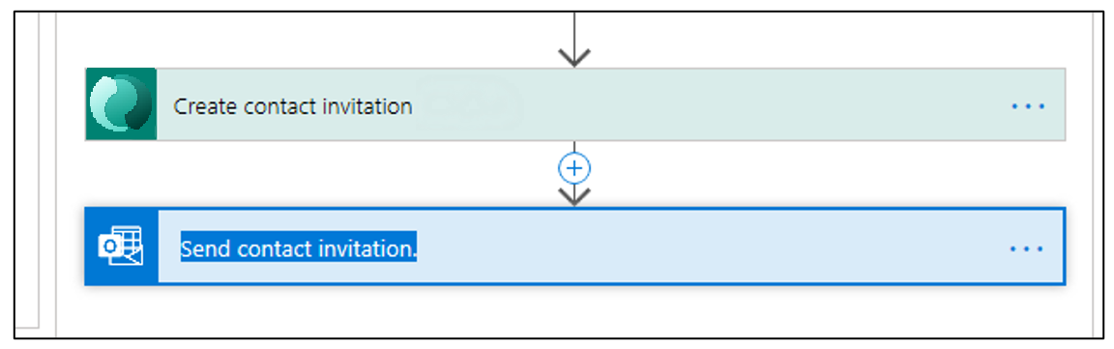

1. Select the **To** column and select **Email** from the **Dynamic content** pane.

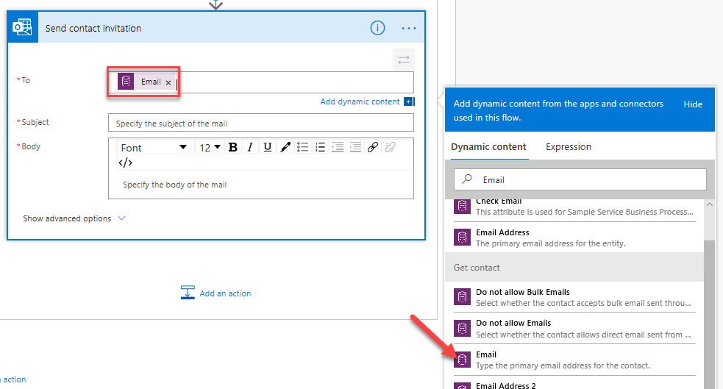

1. Type **Resolved:** and select **Case Title** from the **Dynamic content** pane.

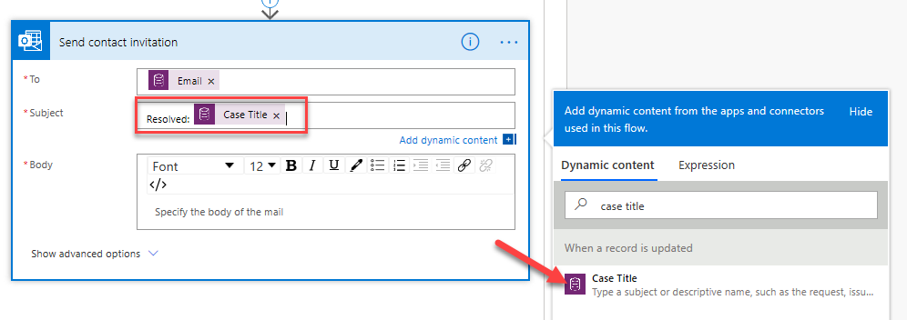

1. Type **Hello** in the **Body** column and select **First Name** from the **Dynamic content** pane.
2. Add a **comma** after the first name and press the **Enter** key twice.
3. Type **We recently resolved the following case for you:** and then press the **Enter** key.
4. Type **Case Number:** and select **Case Number** from the **Dynamic content** pane. Press the **Enter** key.
5. Type **Case Title:** and select **Case Title** from the **Dynamic content** pane. Press the **Enter** key twice.
6. Enter **In order to provide the best quality service to you, please take few moments to let us know how we did.** Press the **Enter** key twice.
7. Switch to **Code View** by selecting the **</>** button.

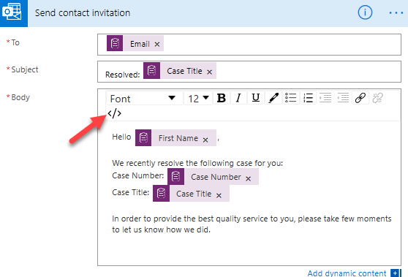

1. Enter **<a href="">Complete Feedback Survey</a>** and then place your cursor between the two double quotation marks.

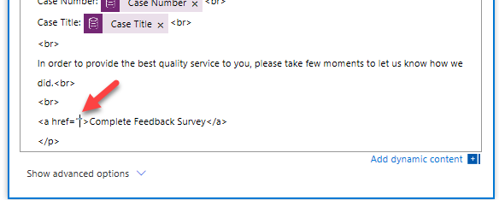

1. Select **Invitation link** from the **Dynamic content** pane.

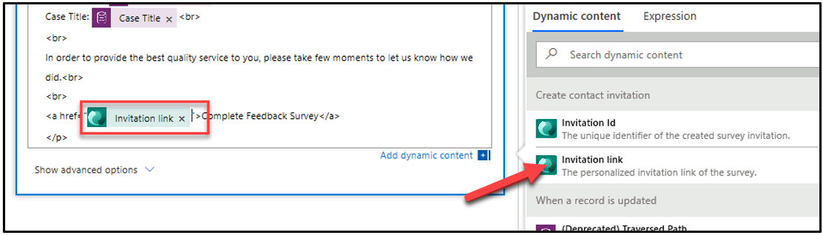

1. Type **<br> <br>** and then press the **Enter** key.
2. Type **Thanks for your business <br><br>**.

Your email should now look like the following image.

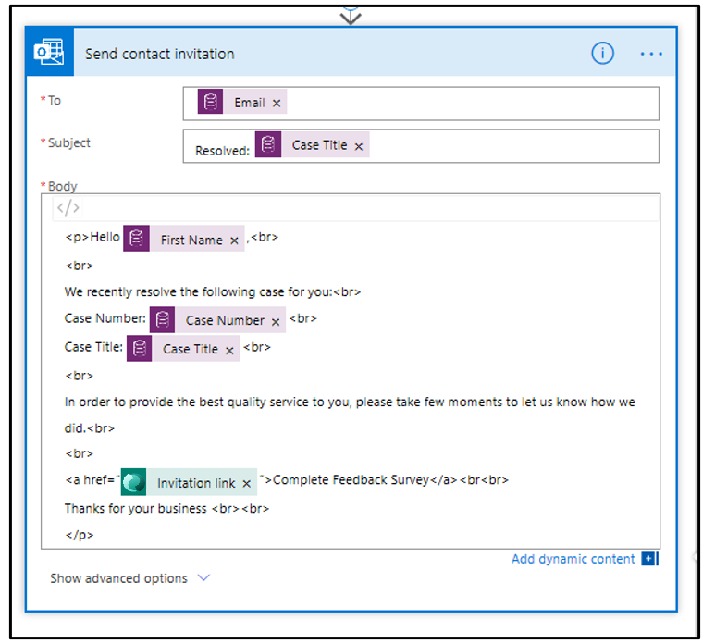

1. Select **Save**.

## Task 8: Test the send survey invitation

In this task, you will test the send survey invitation flow.

1. Go to your Dynamics 365 **Sales Hub** application.
2. Select **Cases** and select to open the case that you created.

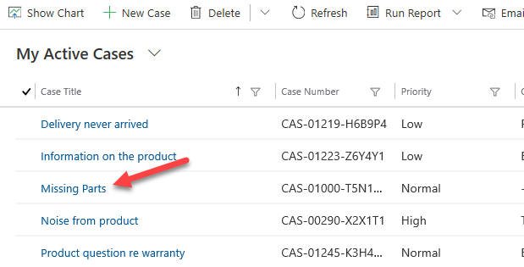

1. Select **Resolve Case**.

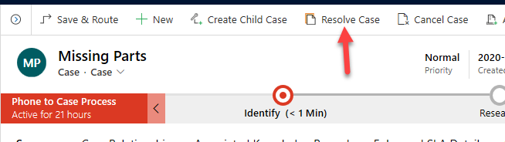

1. Enter **Sent replacement parts** for **Resolution**, select **30 minutes** for **Billable Time**, and select **Resolve**.

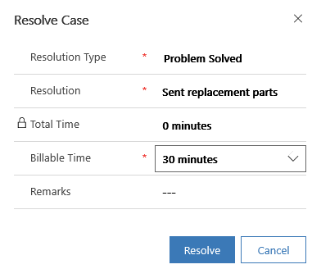

You should get an email from the flow.

1. Select to open the email.

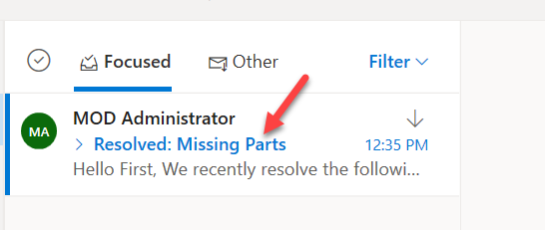

1. Your survey invitation email should look like the following image. Select the survey link.

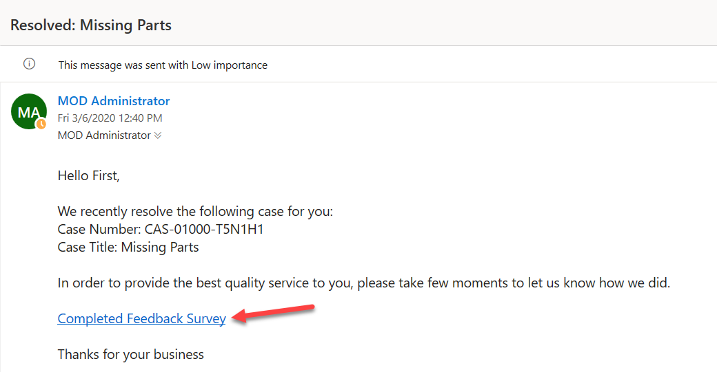

The survey should load.

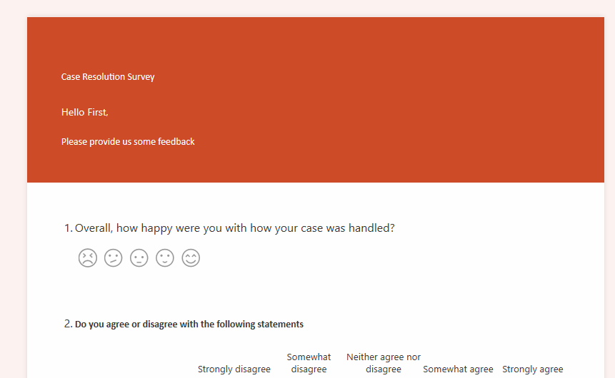

1. Close the survey browser window or tab.

# Exercise 3: Adding image viewer in Product form

Prerequisites:

* 2021 Release Wave 2 installed on instance.
* Demo data for Products imported (see Lab Assets)

## Task 1: Create New Model Driven App

1. Sign into Power Apps
2. On the left navigation pane, select Solutions and then open or create a solution to contain the new model-driven app.
3. Select New > App > Model-driven app
4. Select Modern app designer, and then select Create.

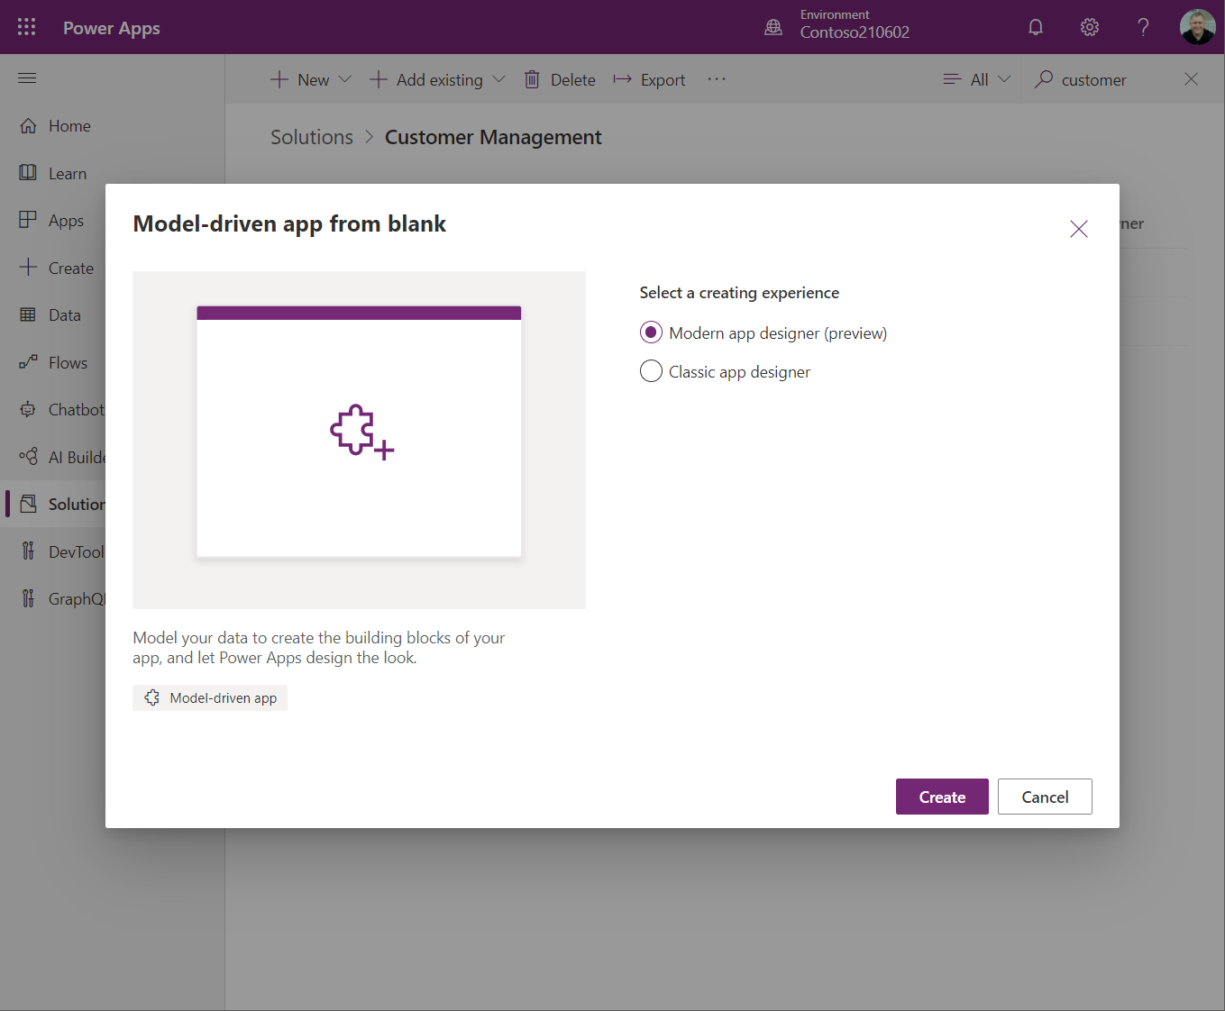

1. Enter Product Management as **Name** for your app, and then select **Create.**

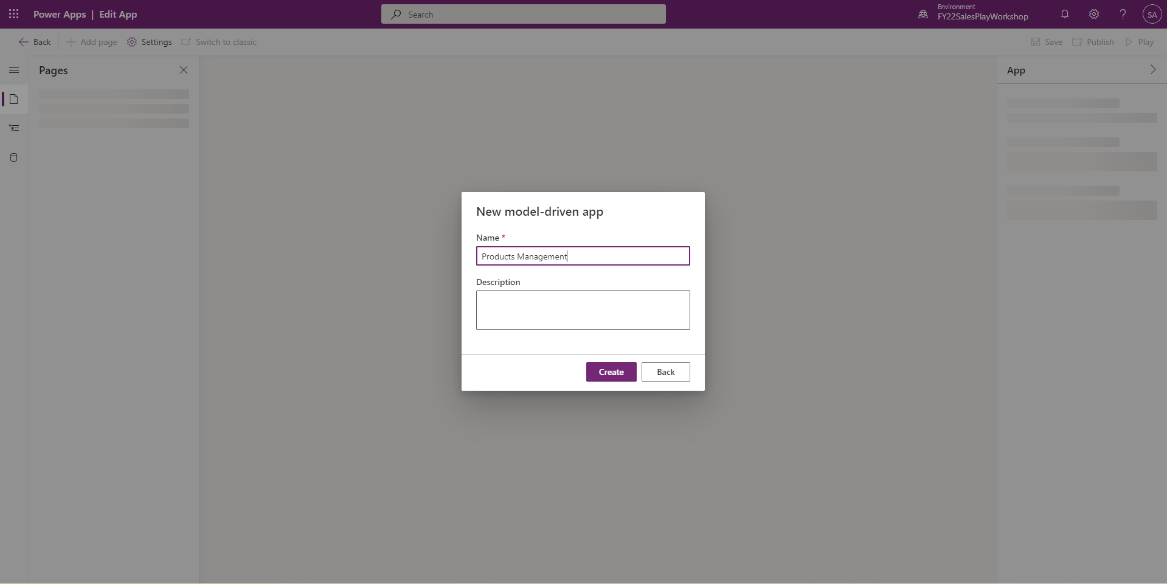

## Task 2: Edit the command bar

1. Make sure you **Publish** your app before you work with the command designer.
2. **Add Page** within your model driven app and select **Table base view and form** and choose Product.

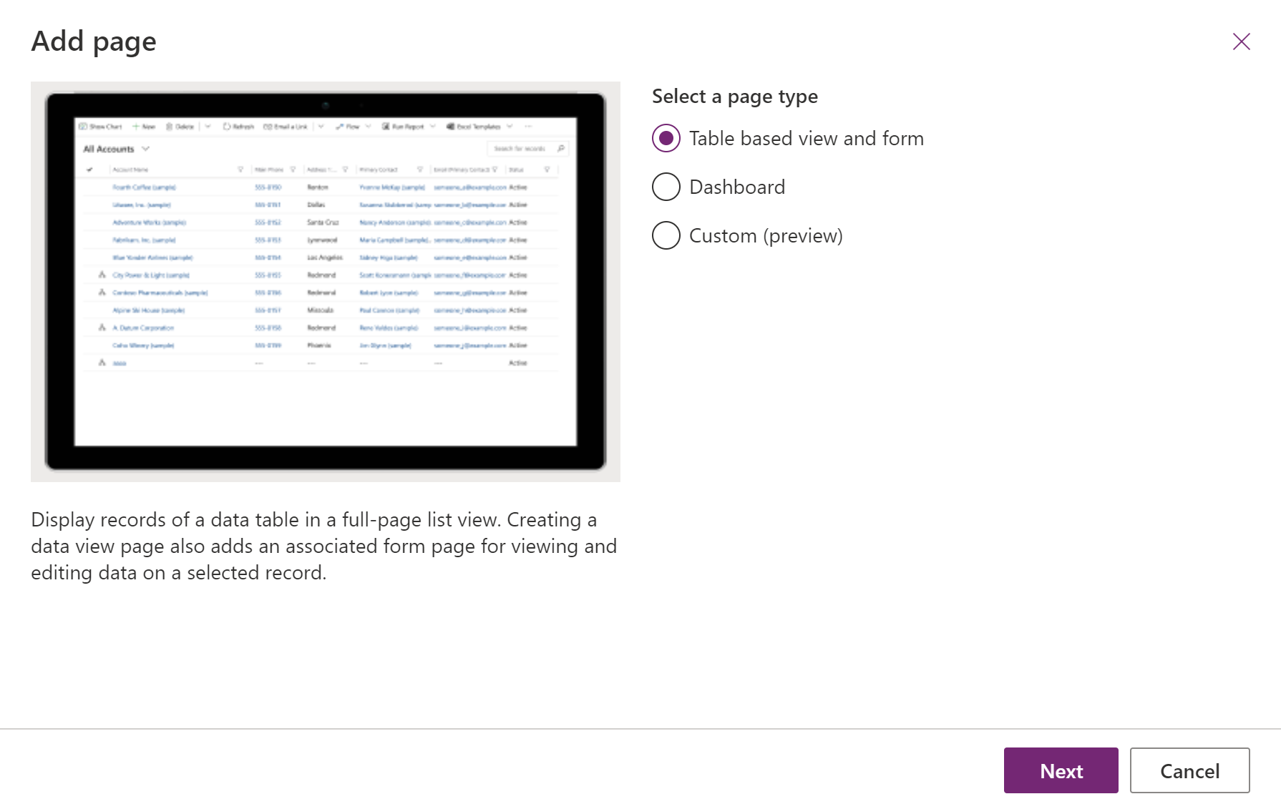

1. Open the command designer to edit a command bar

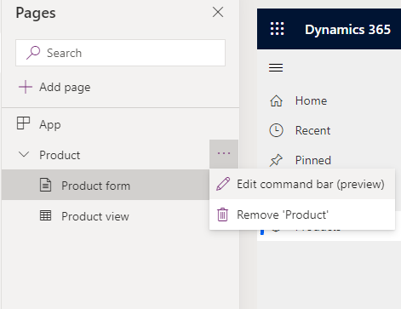

1. Select any table from the **Pages** area in the app designer.
2. Select **...** and then select **Edit command bar**.

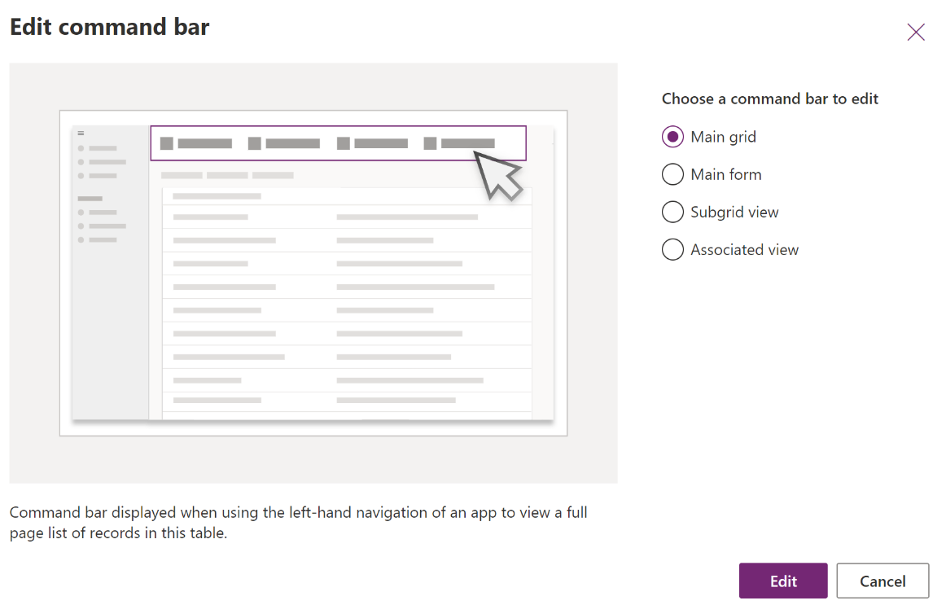

1. Select **Subgrid view**, and then select **Edit**.

## **Task 3: Create a new command**

1. [Open the command designer to edit a command bar](https://docs.microsoft.com/en-gb/powerapps/maker/model-driven-apps/use-command-designer#open-the-command-designer-to-edit-a-command-bar), and then select **+ New** on the command designer command bar.

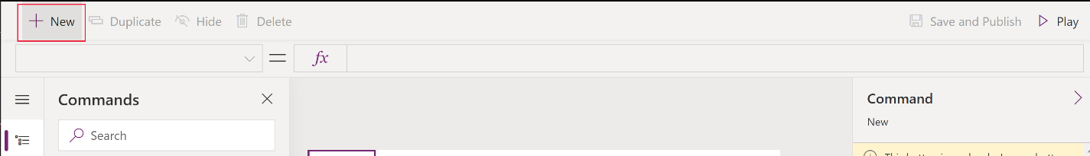

1. On the right pane, enter or select from the following options:

* **Label**. Enter “View Image” as label that will be displayed on the command button.
* **Icon**. Select an icon for the command button. You may choose from any system icons or web resource SVG files. For this, select **Use Icon**, and **View** as icon.
* **Tooltip title**. Enter “View product image“ as tooltip title. The title appears to the user when they hover their mouse over the command.
* **Tooltip description**. Enter “View product image from record url” as tooltip description. The description appears for the user below the tooltip title when they hover their mouse over the command.
* **Action**. Select **Run formula** and enter the Power Fx formula to run the command action

|  |
| --- |
| Launch(Self.Selected.Item.URL,{}, LaunchTarget.New) |

* **Visibility**. Select to **Always show**.
* Drag and drop the command to the desired location. You can arrange modern commands amongst classic commands.

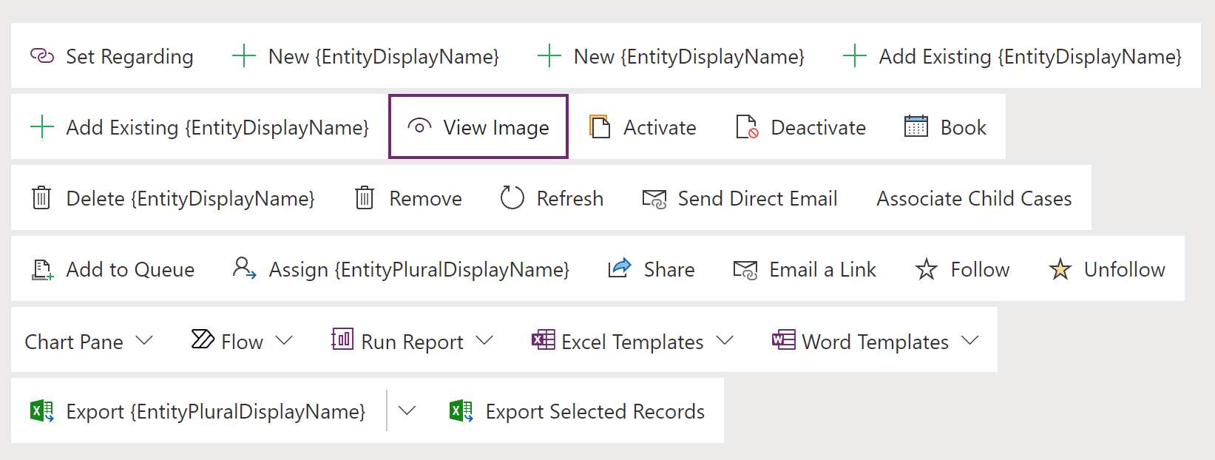

* Select **Play** to run the command or **Save and Publish** to make the command available to app users.

## Task 4: Test the command button from Product form

* + 1. Open [Power Apps](https://make.powerapps.com/).
    2. Select Product Management app and Play

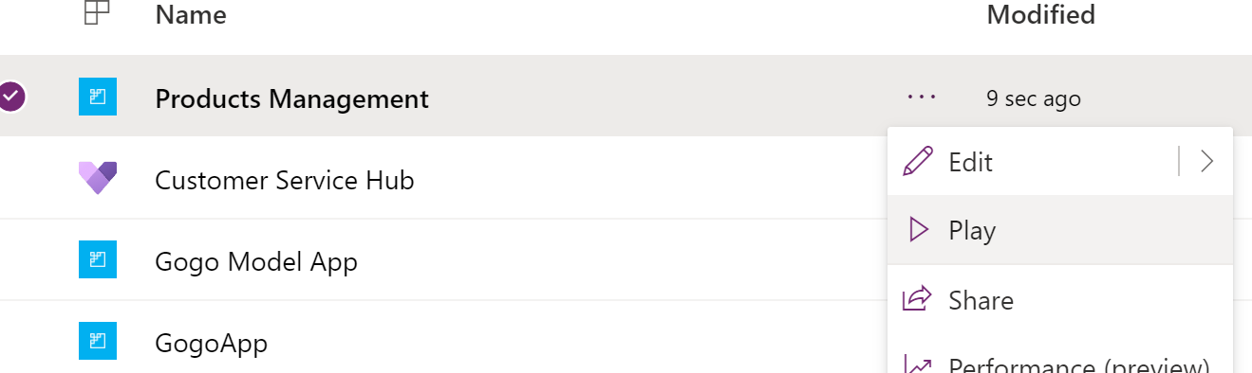

* + 1. Navigate to Product and change the view to All Product, Families & Bundles

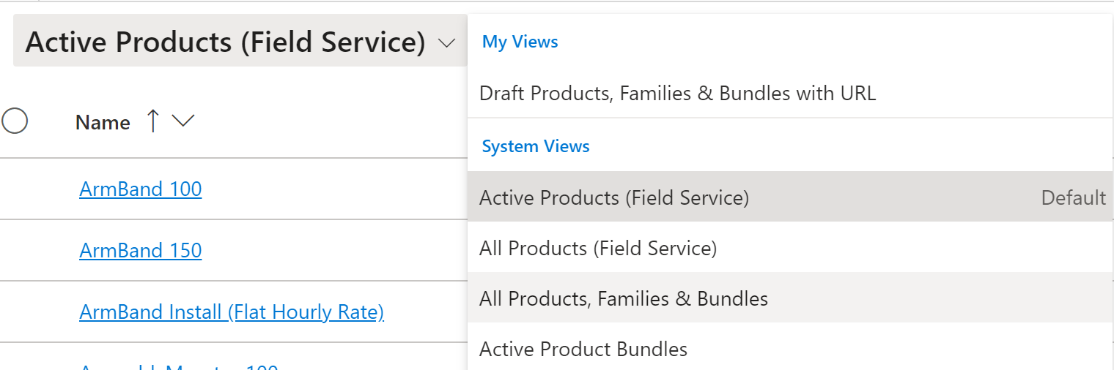

* + 1. Search for Surface Hub and choose any product records uploaded from template.

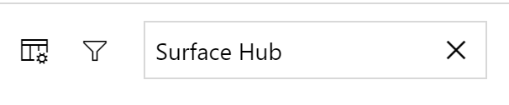

* + 1. You will see View Image button is visible within the form.



* + 1. Click the button and it will open new tab displaying product image.

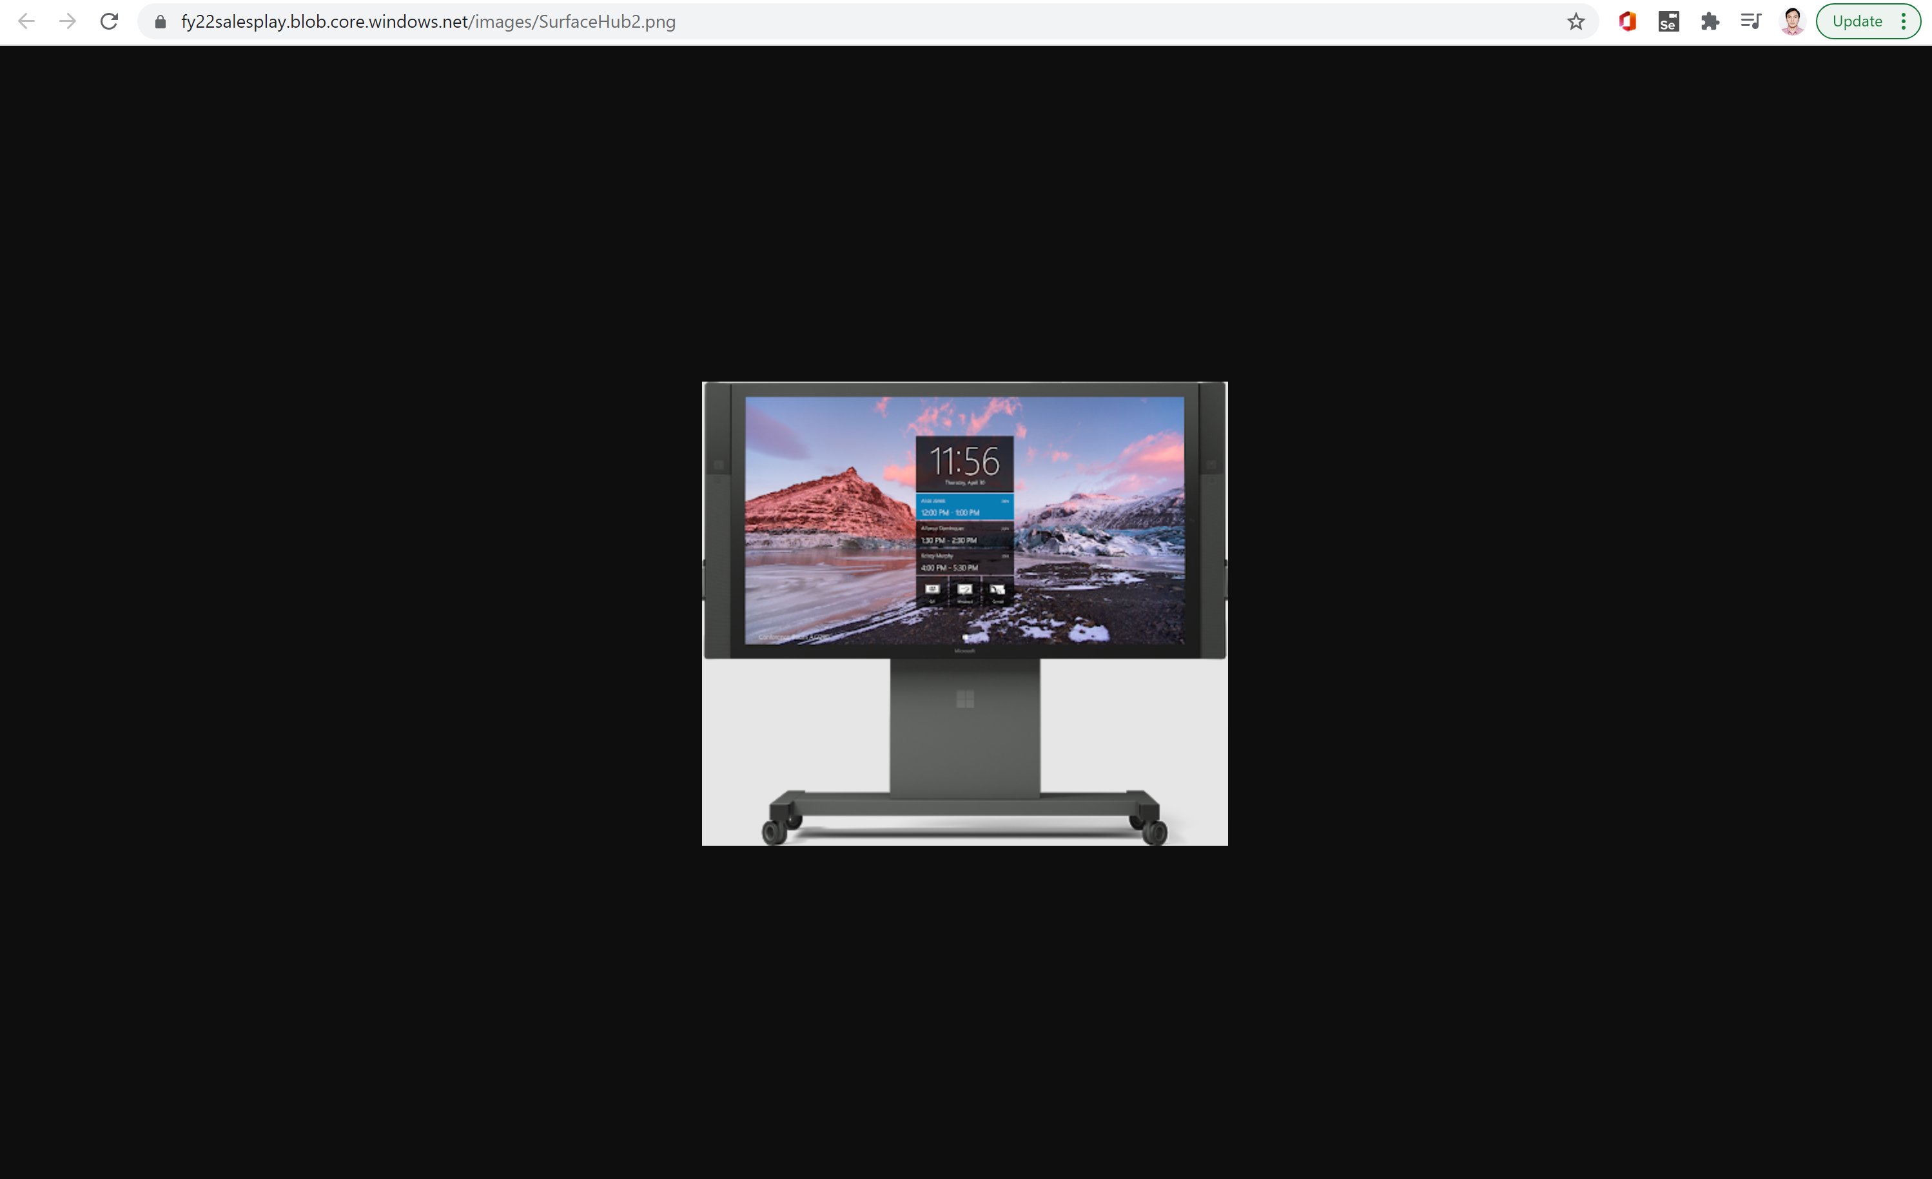

© 2021 Microsoft Corporation. All rights reserved.